C950 Task-2 WGUPS Write-Up

(Task-2: The implementation phase of the WGUPS Routing Program).

(Zip your source code and upload it with this file)

Aaron Ballesteros

ID #011019047

WGU Email: abal387@wgu.edu

04/14/24

C950 Data Structures and Algorithms II

# A. Hash Table

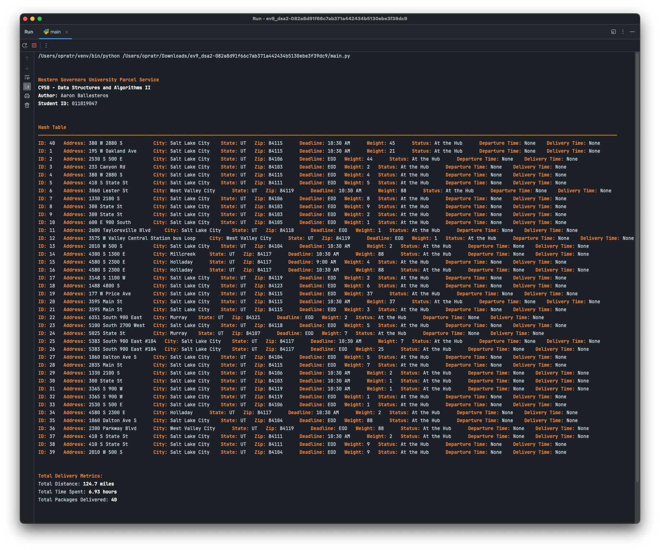

# B. Look-Up Functions

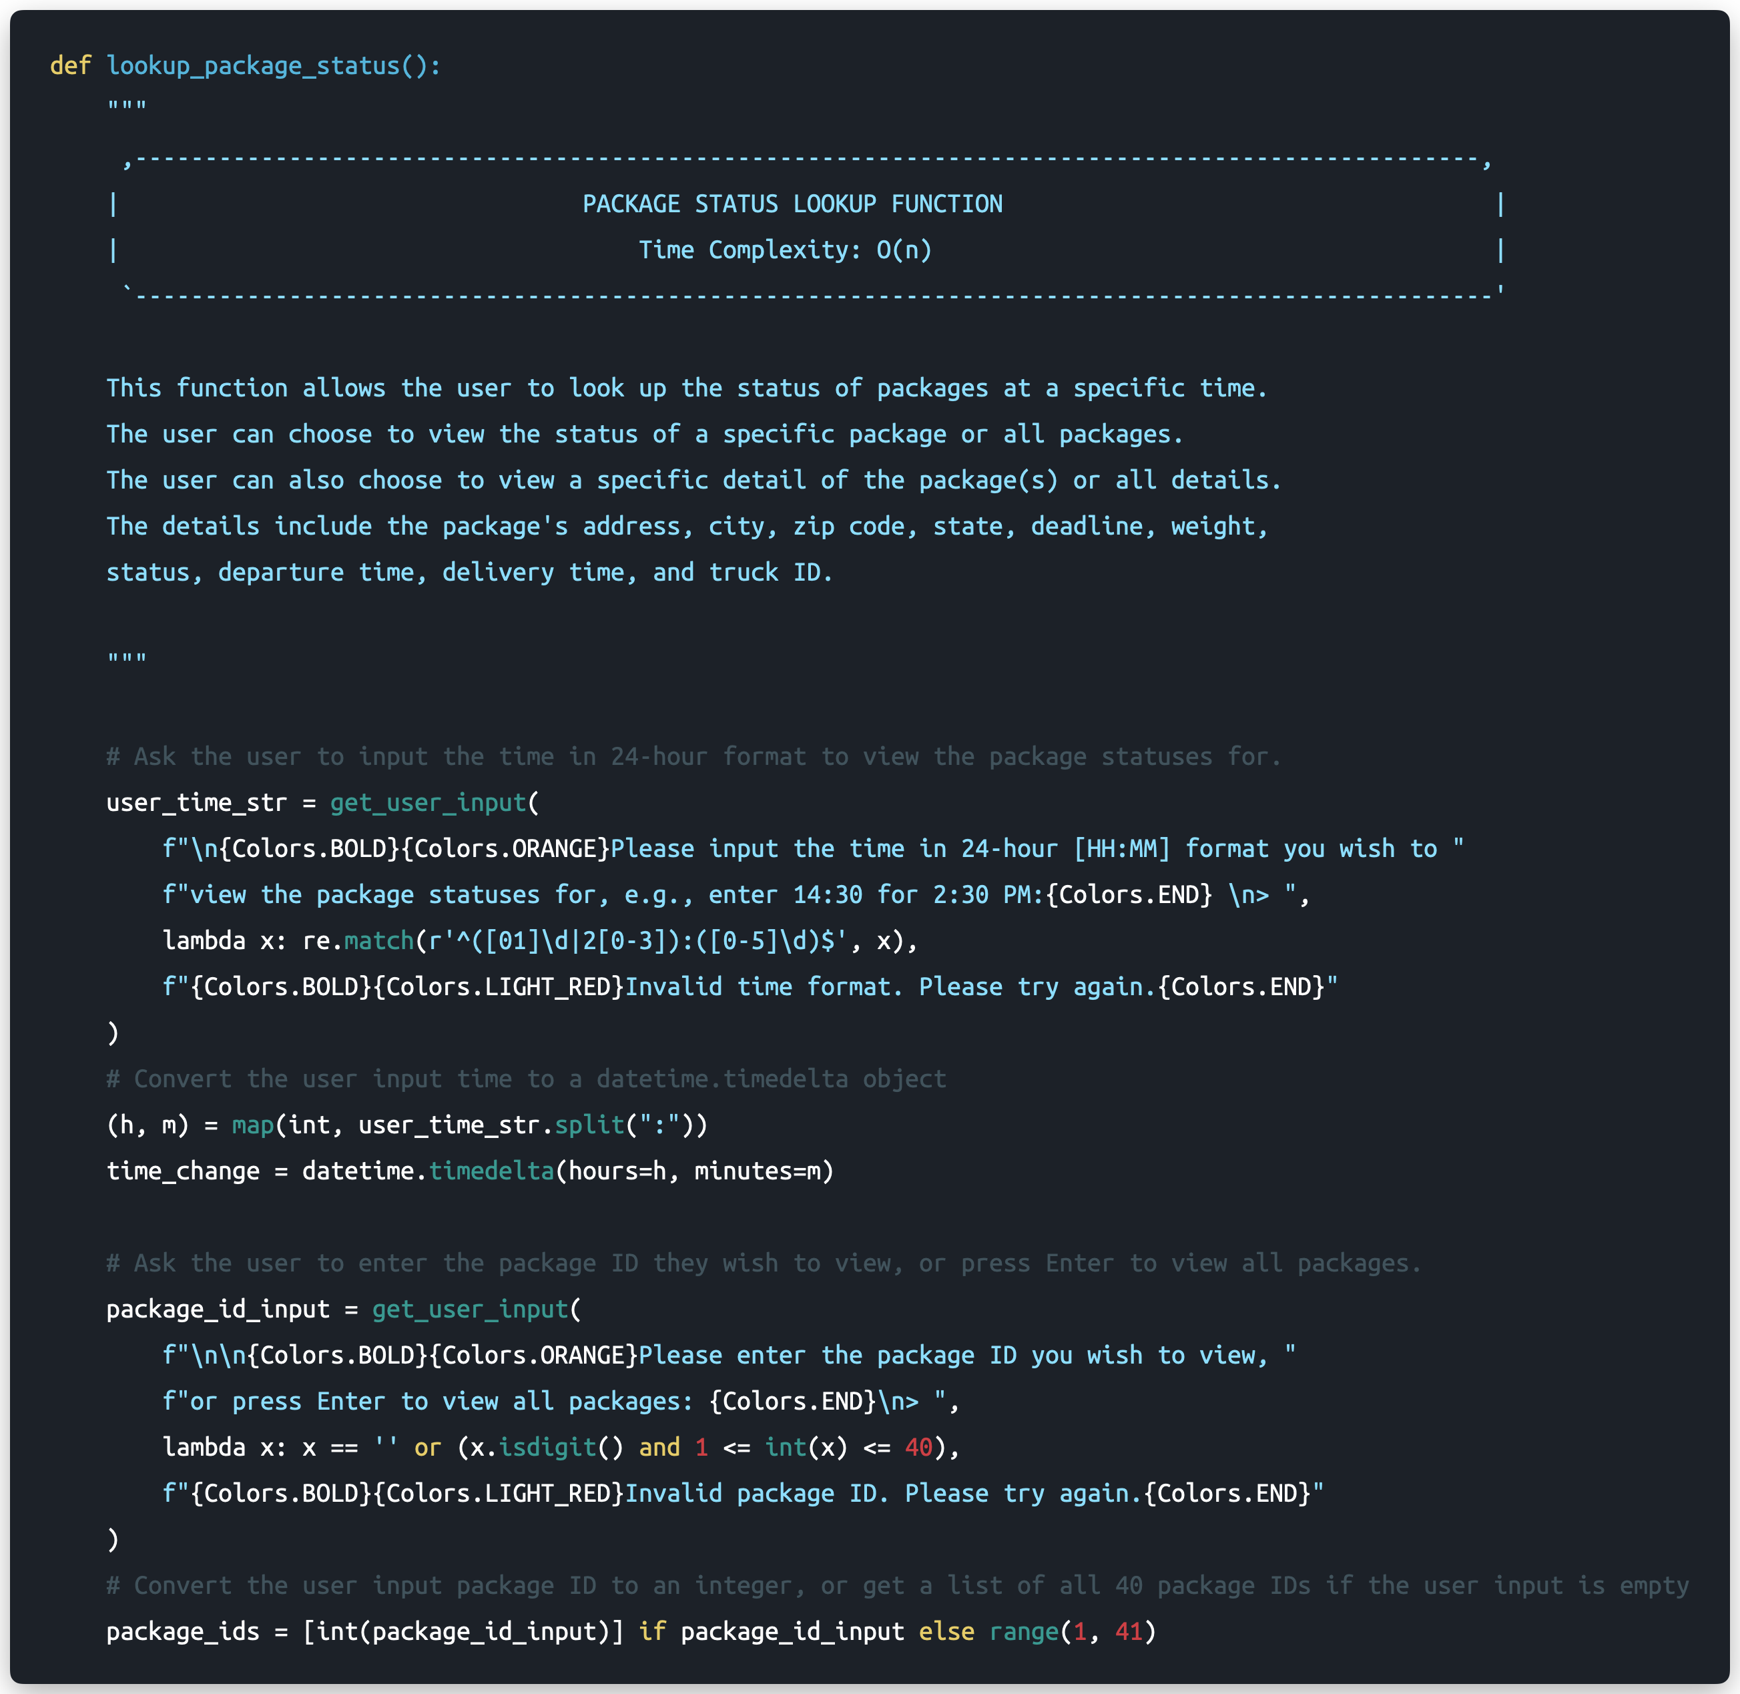

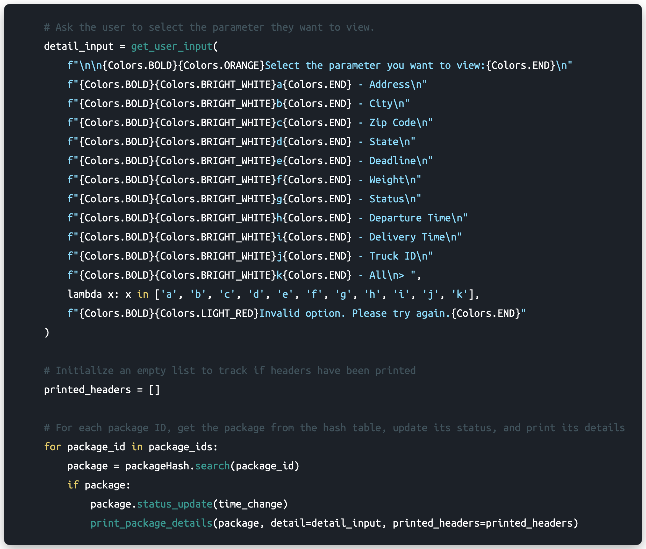

# C. Original Code

Package Class - Implementation

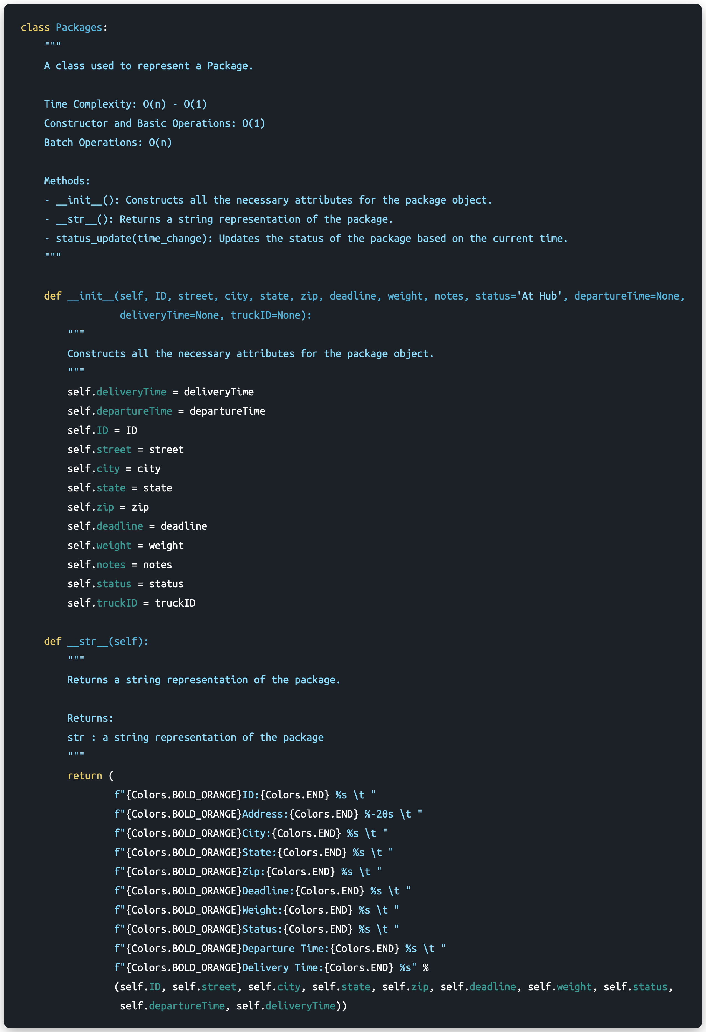

Package Class – Implementation (Continued)

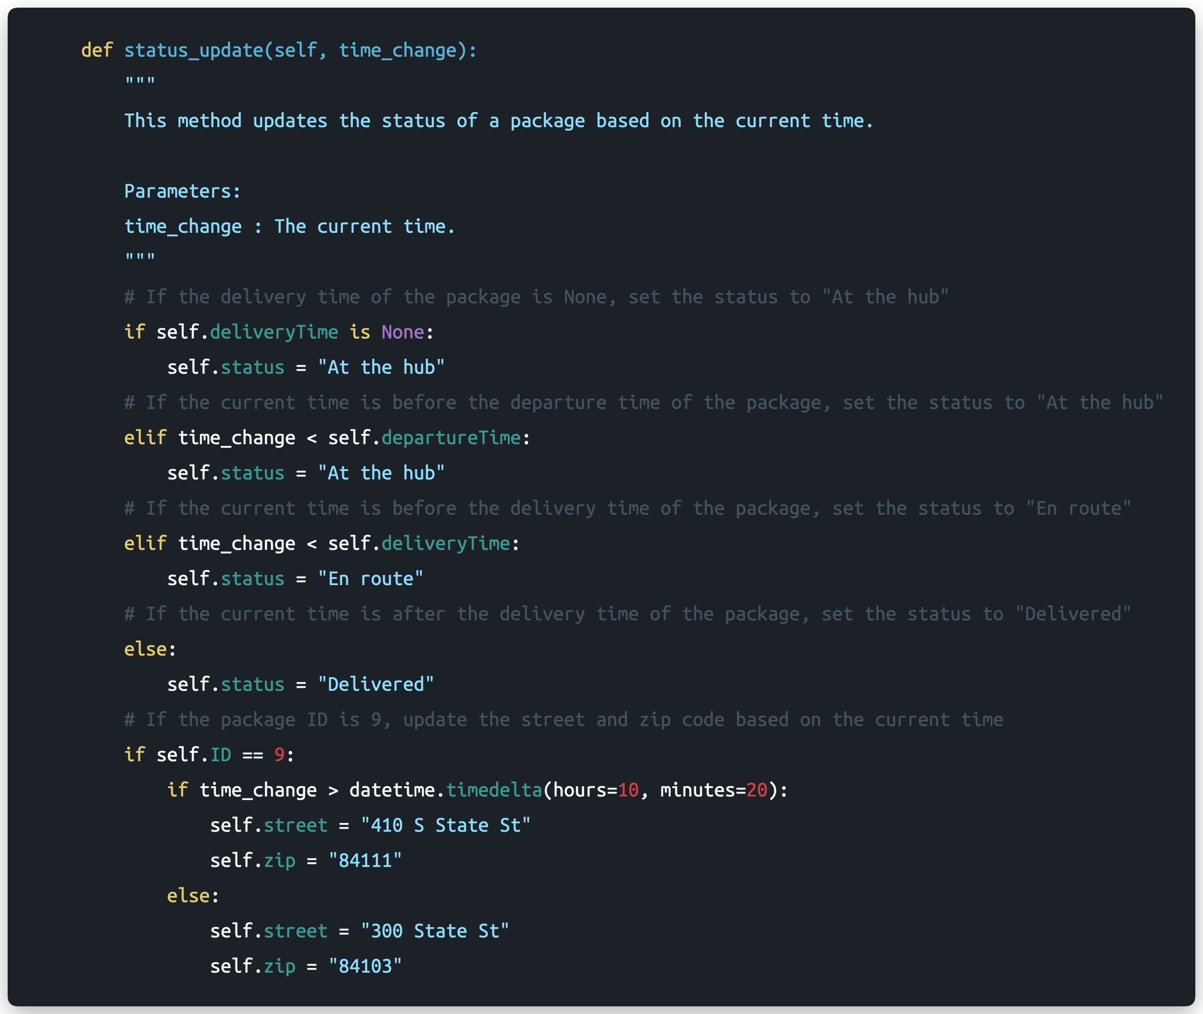

Data Loading – Package Information

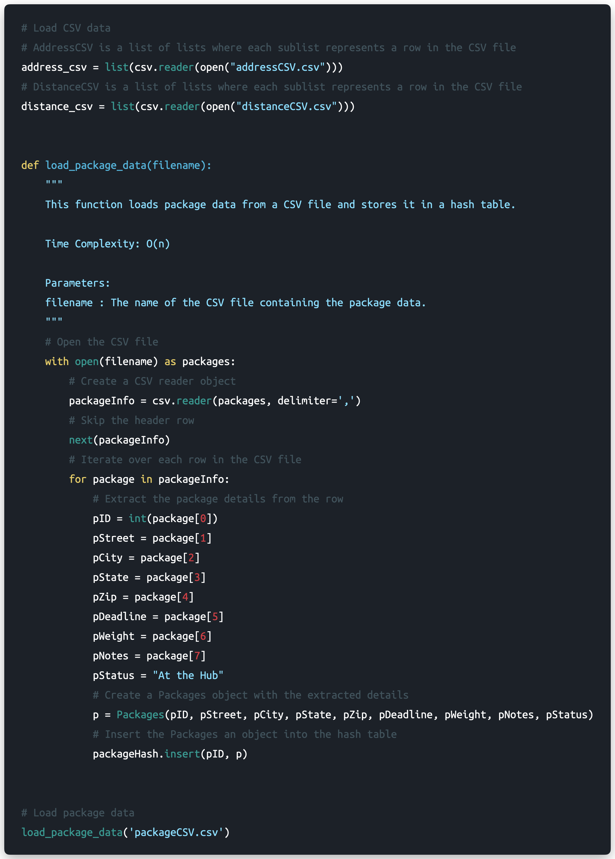

Truck Class - Implementation

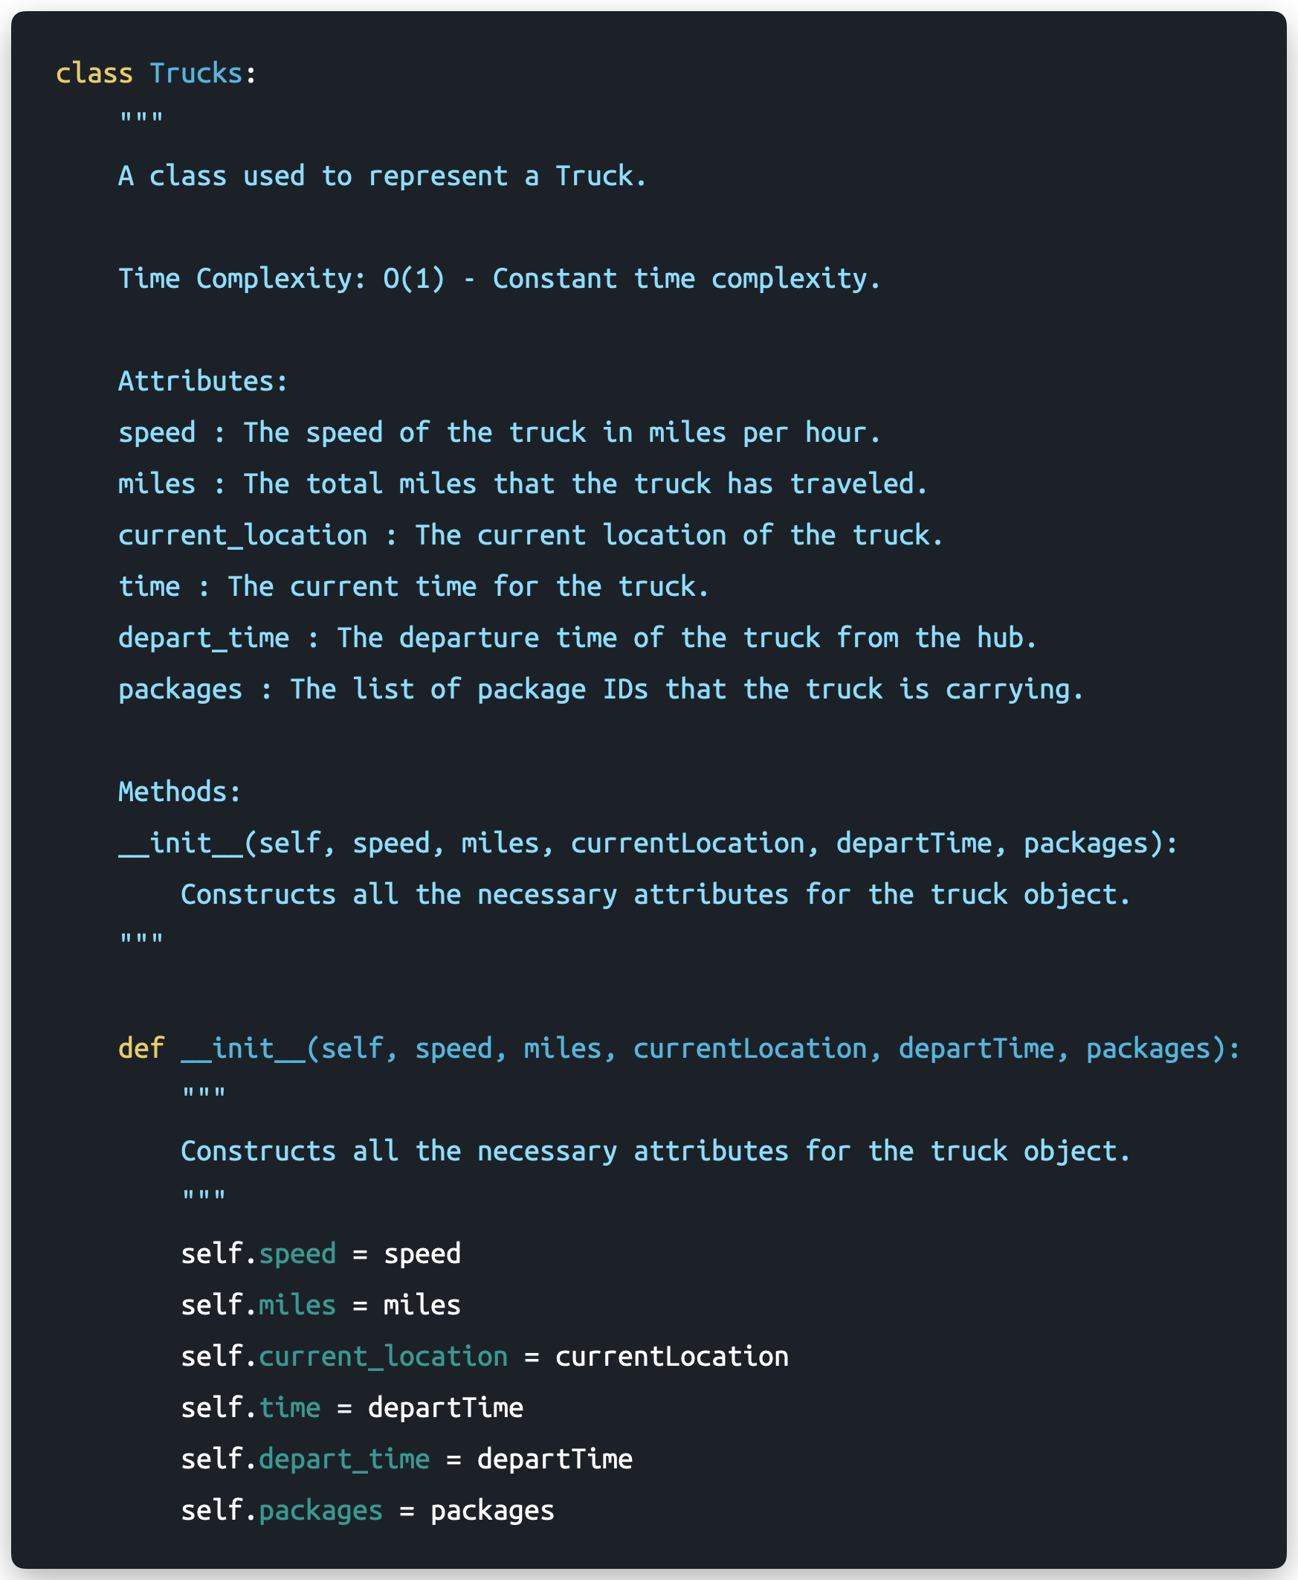

Address Finding Function - Implementation

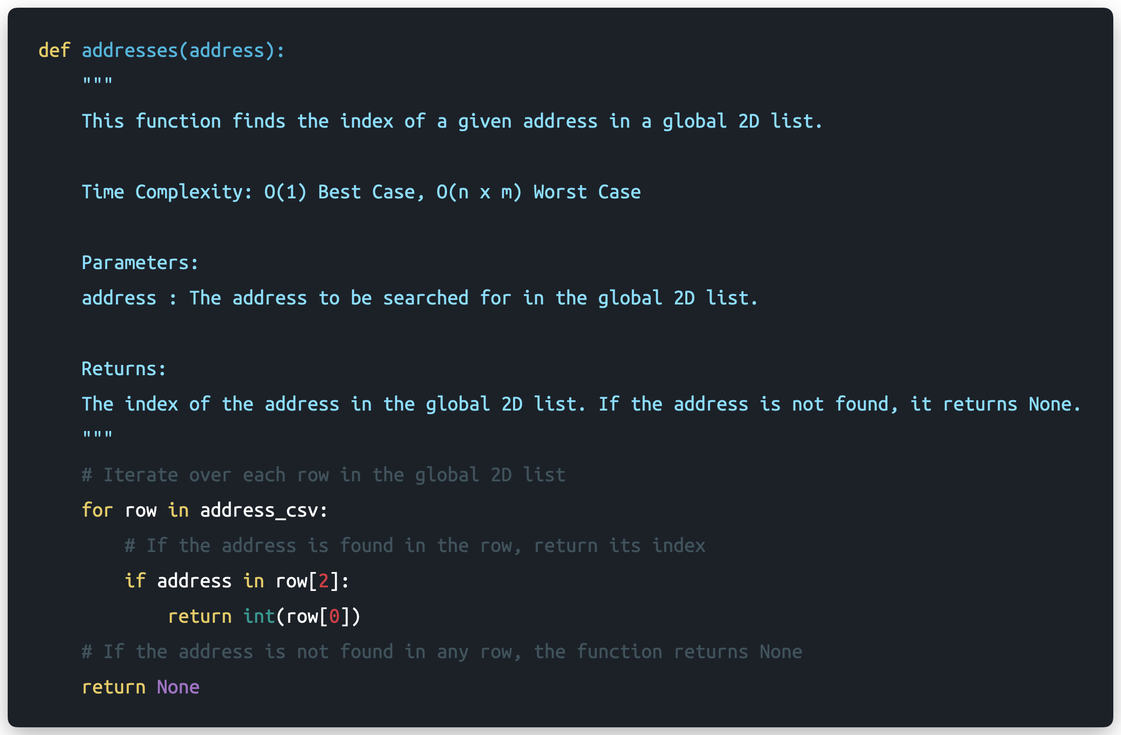

Distance Calculation Function - Implementation

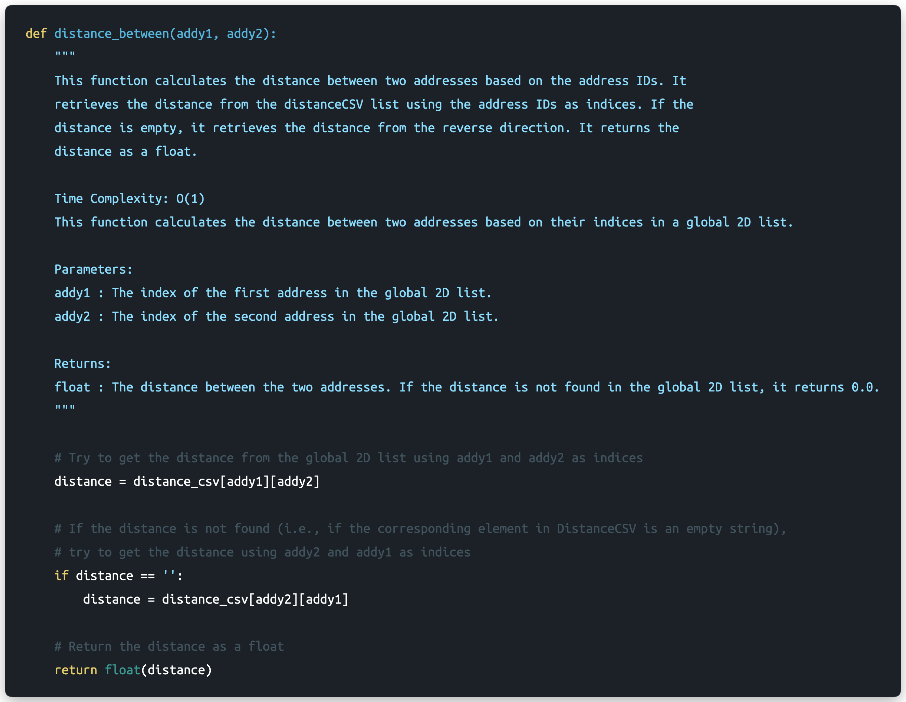

Greedy Algorithm – Implementation

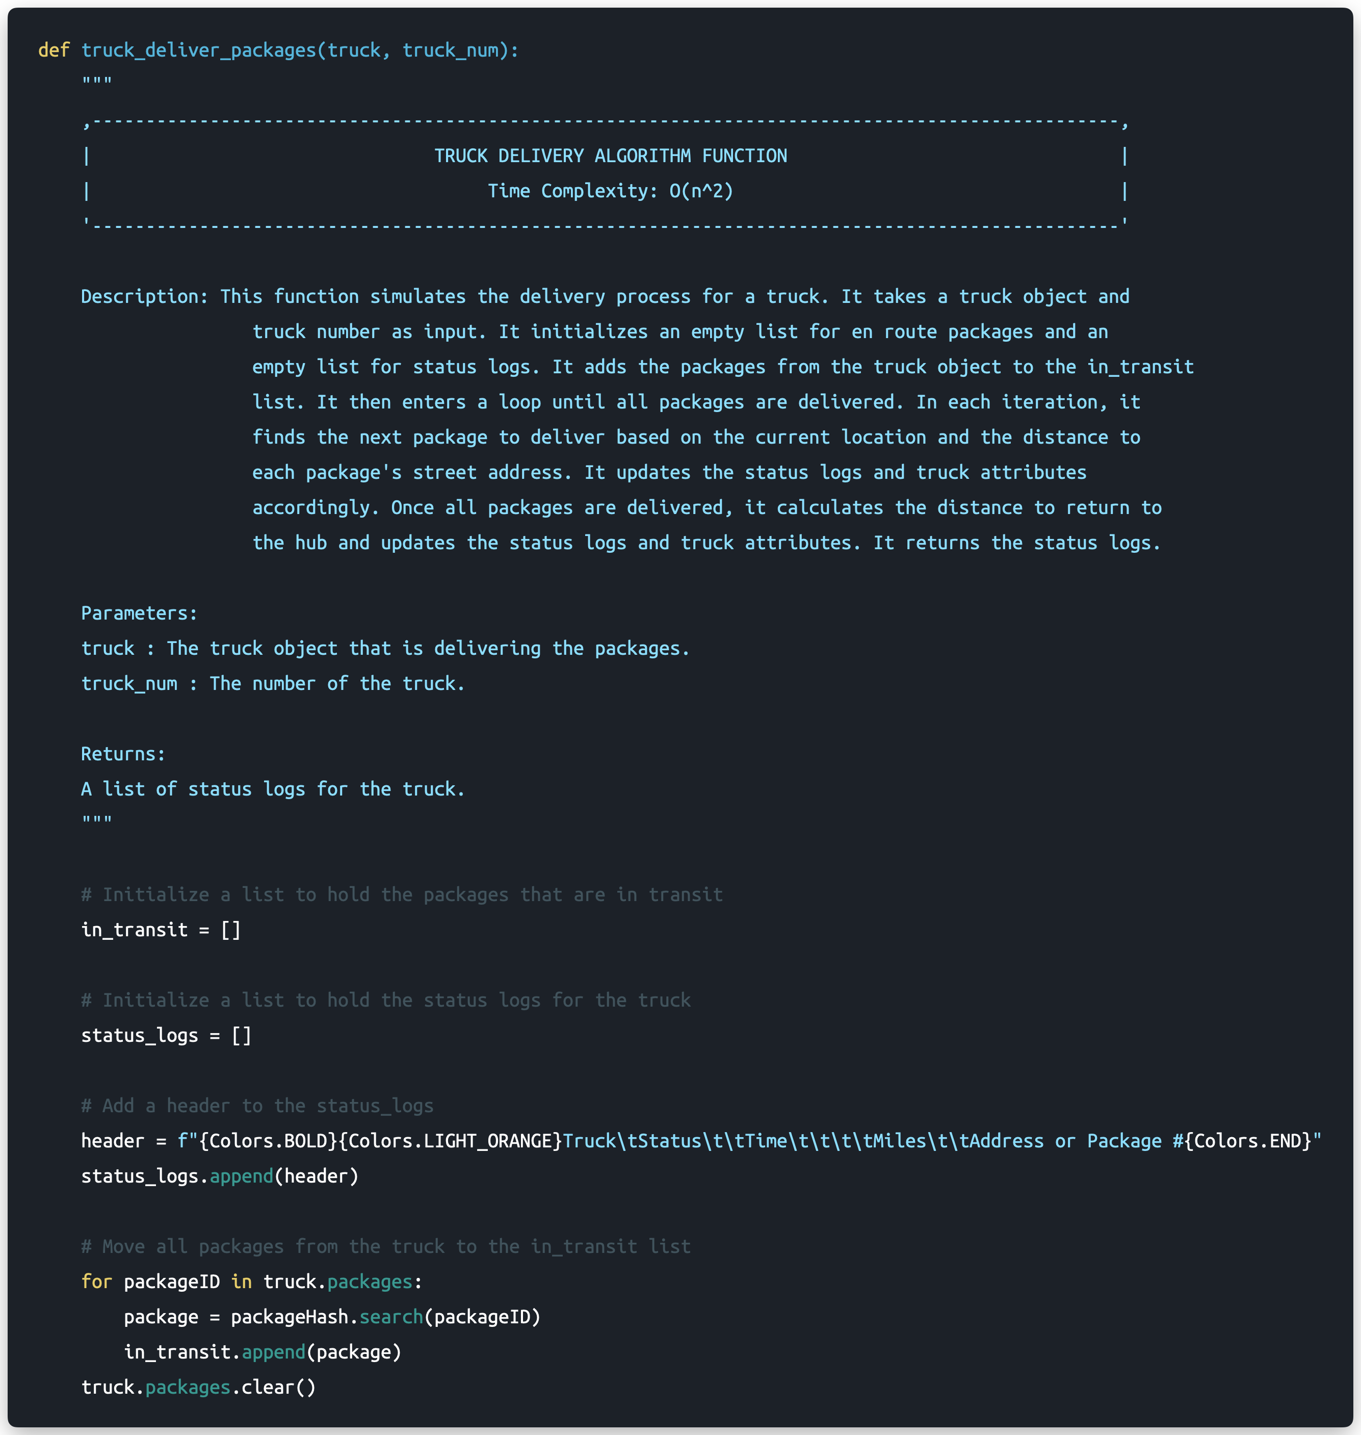

Greedy Algorithm – Implementation (Continued)

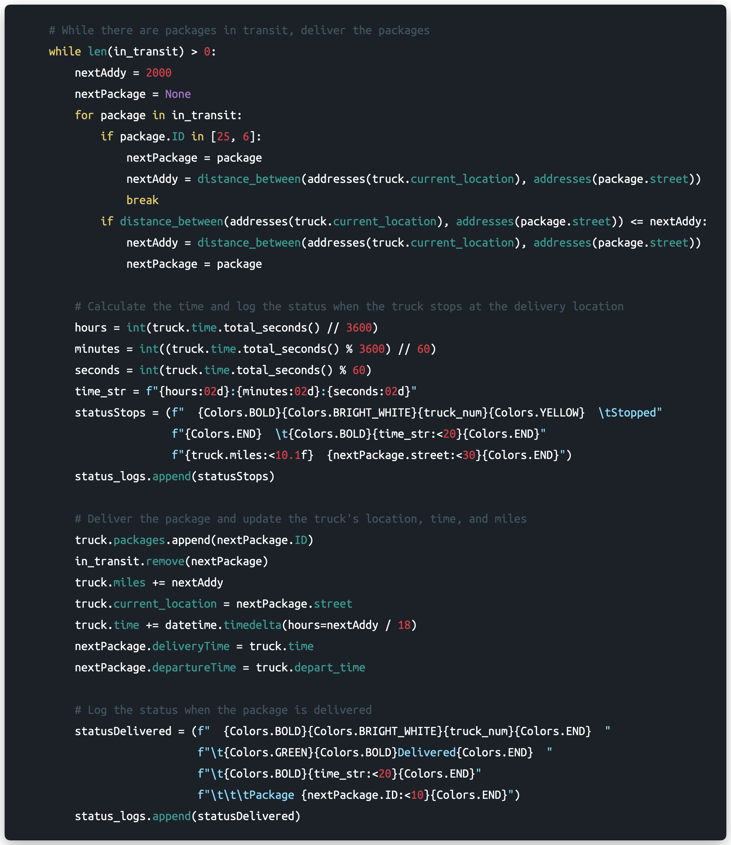

Greedy Algorithm – Implementation (Continued)

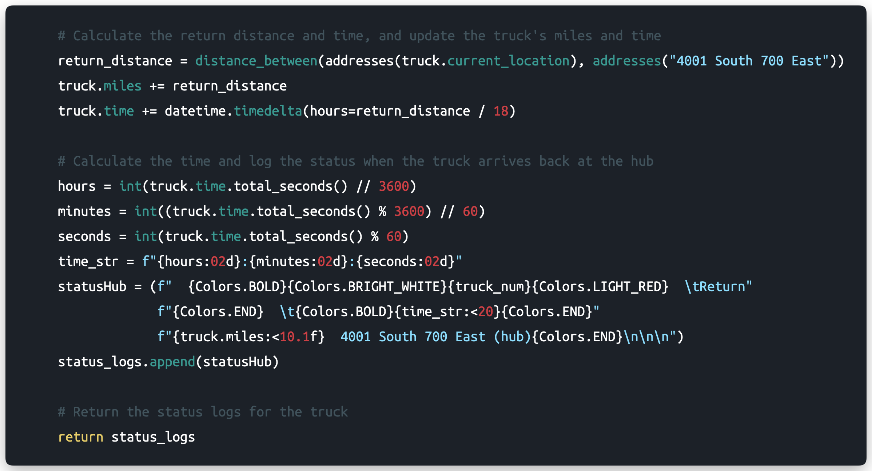

Main Function – Greeting, Hash Table Display, Truck Initialization, Loading, and Setting

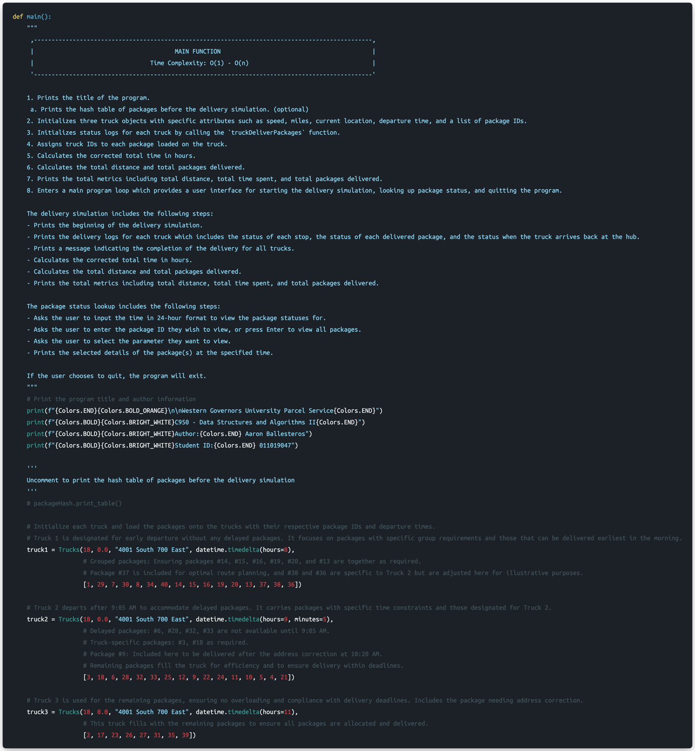

Main Function – Logs, Truck Assignment, Metrics, and Metric Display on Startup (Continued)

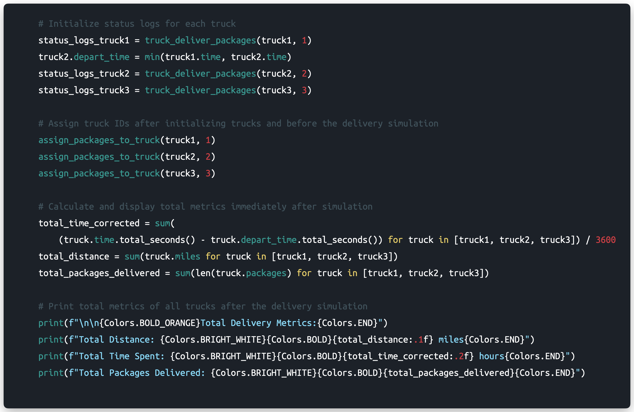

Main Function – Program Loop Implementation

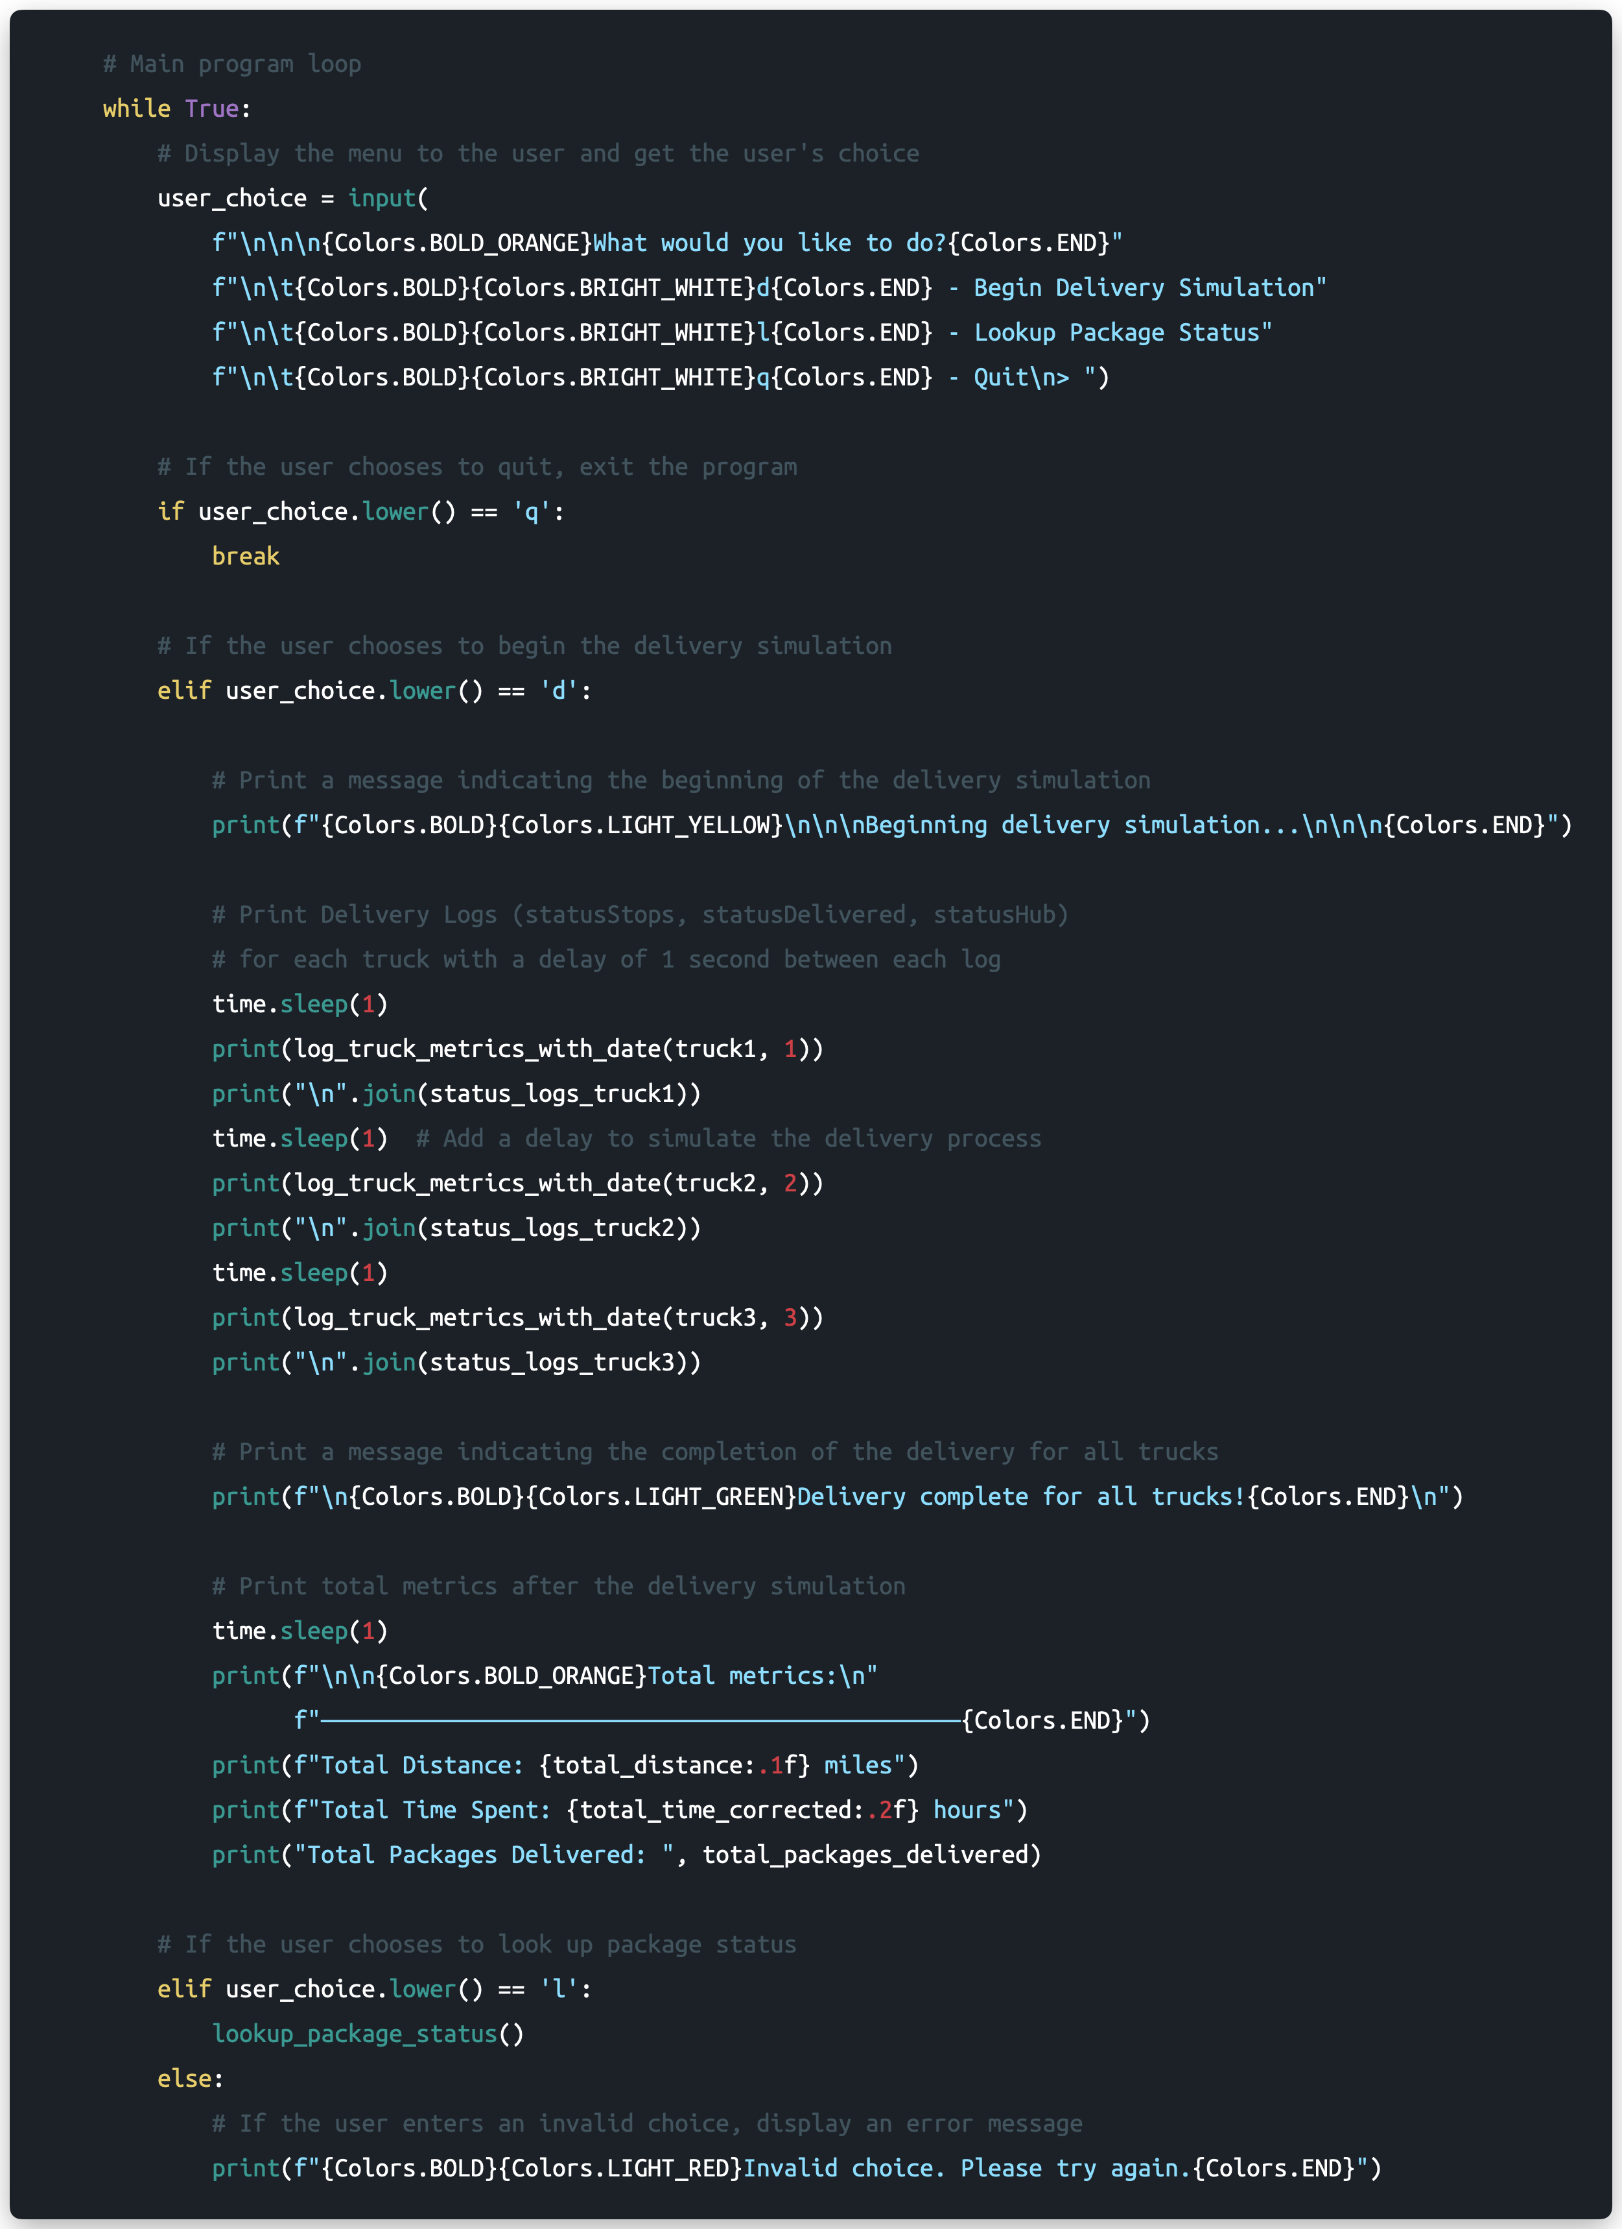

# C1. Identification Information

Identification and Project Information

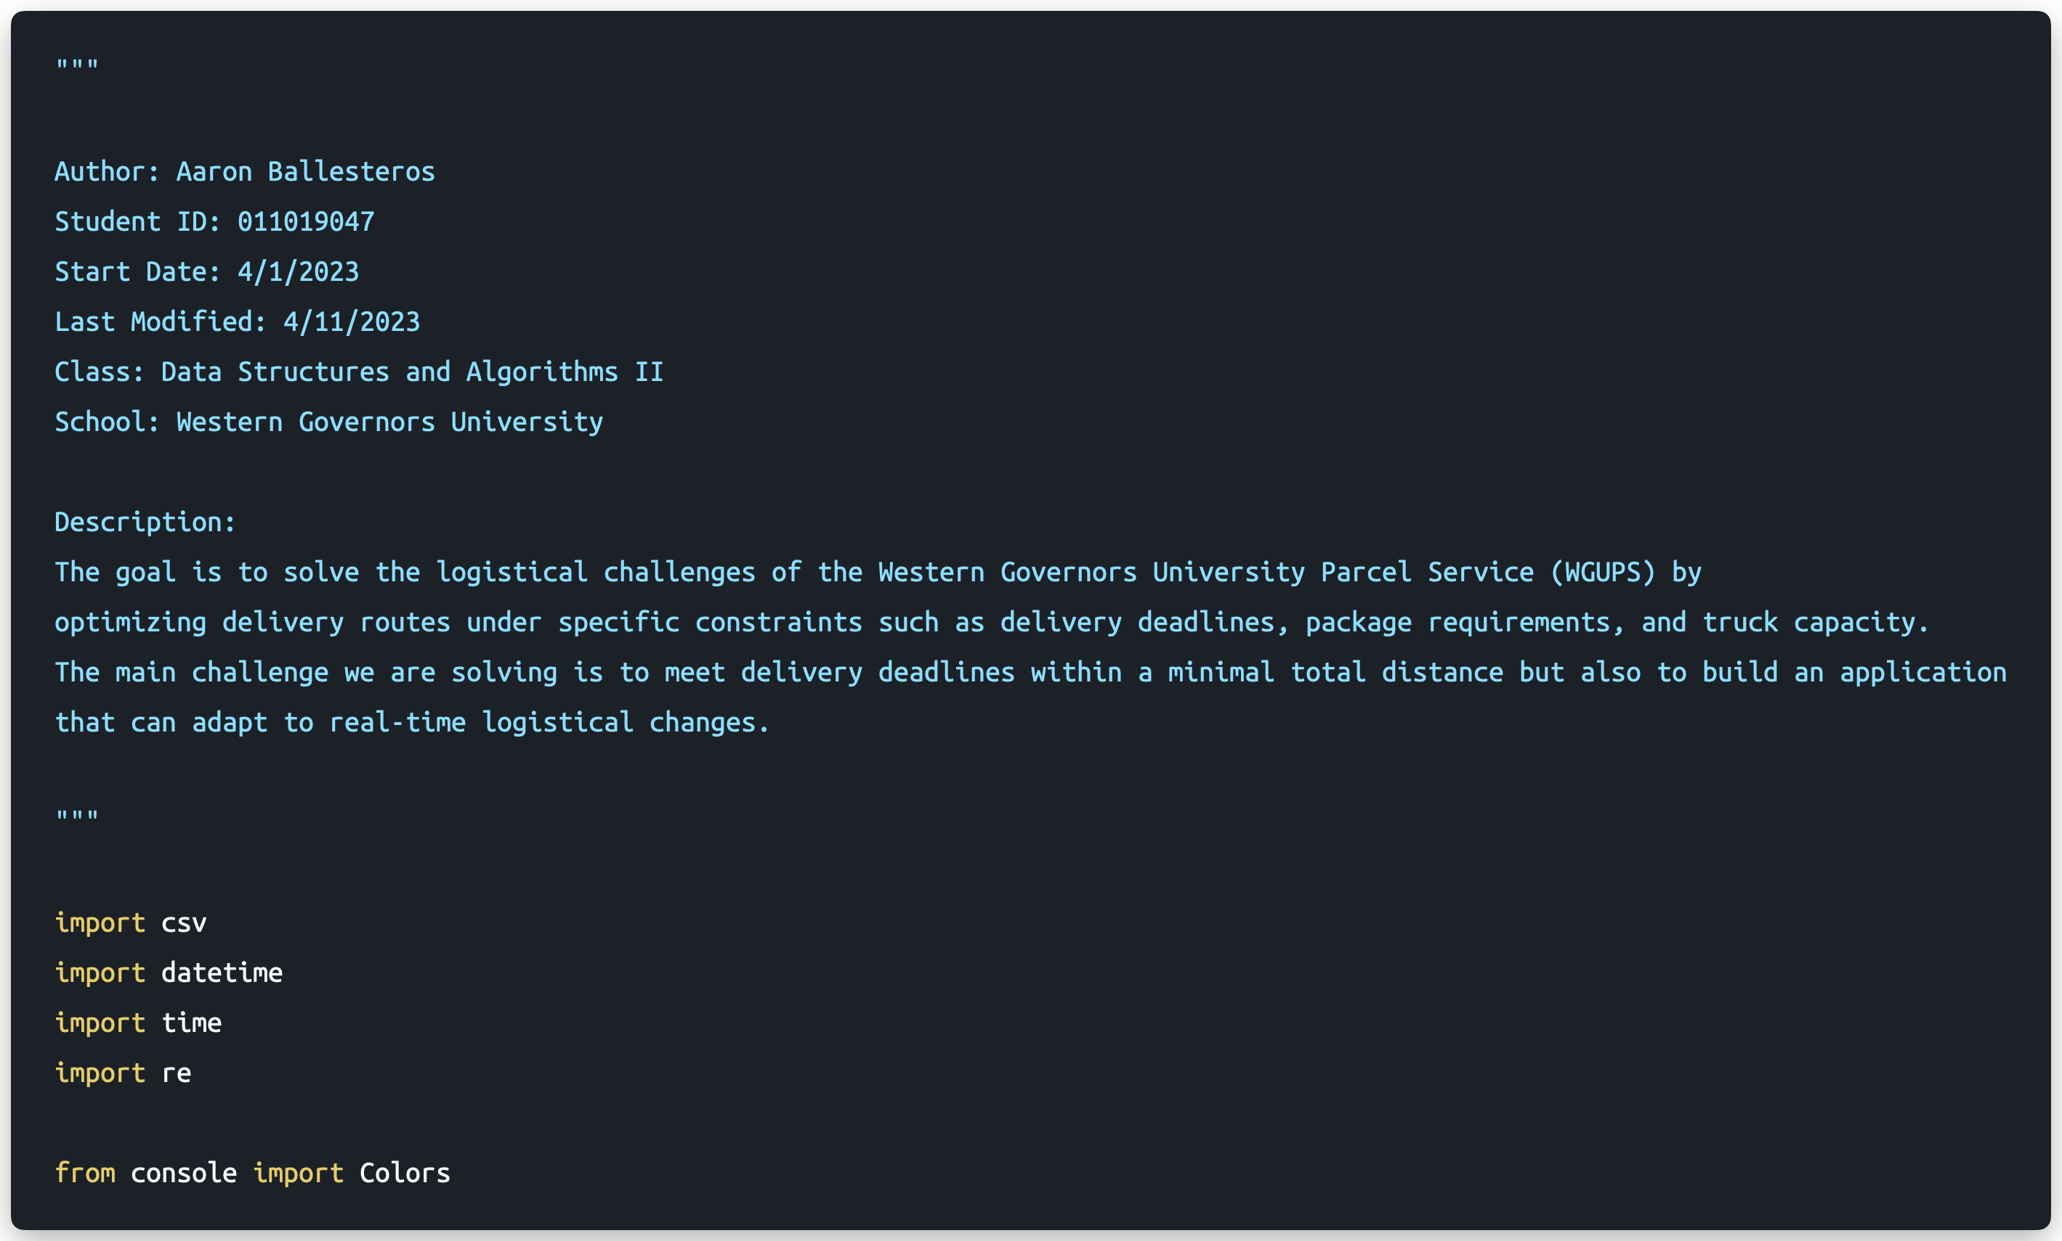

# C2. Process and Flow Comments

Chaining Hash Table – Process and Flow Comments

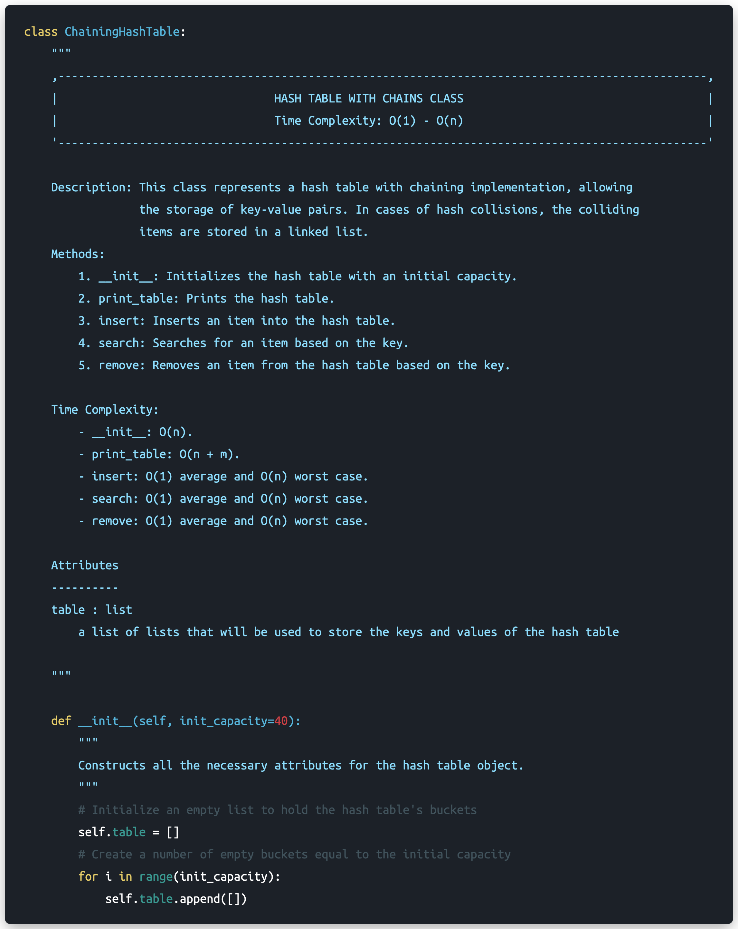

Chaining Hash Table – Process and Flow Comments (Continued)

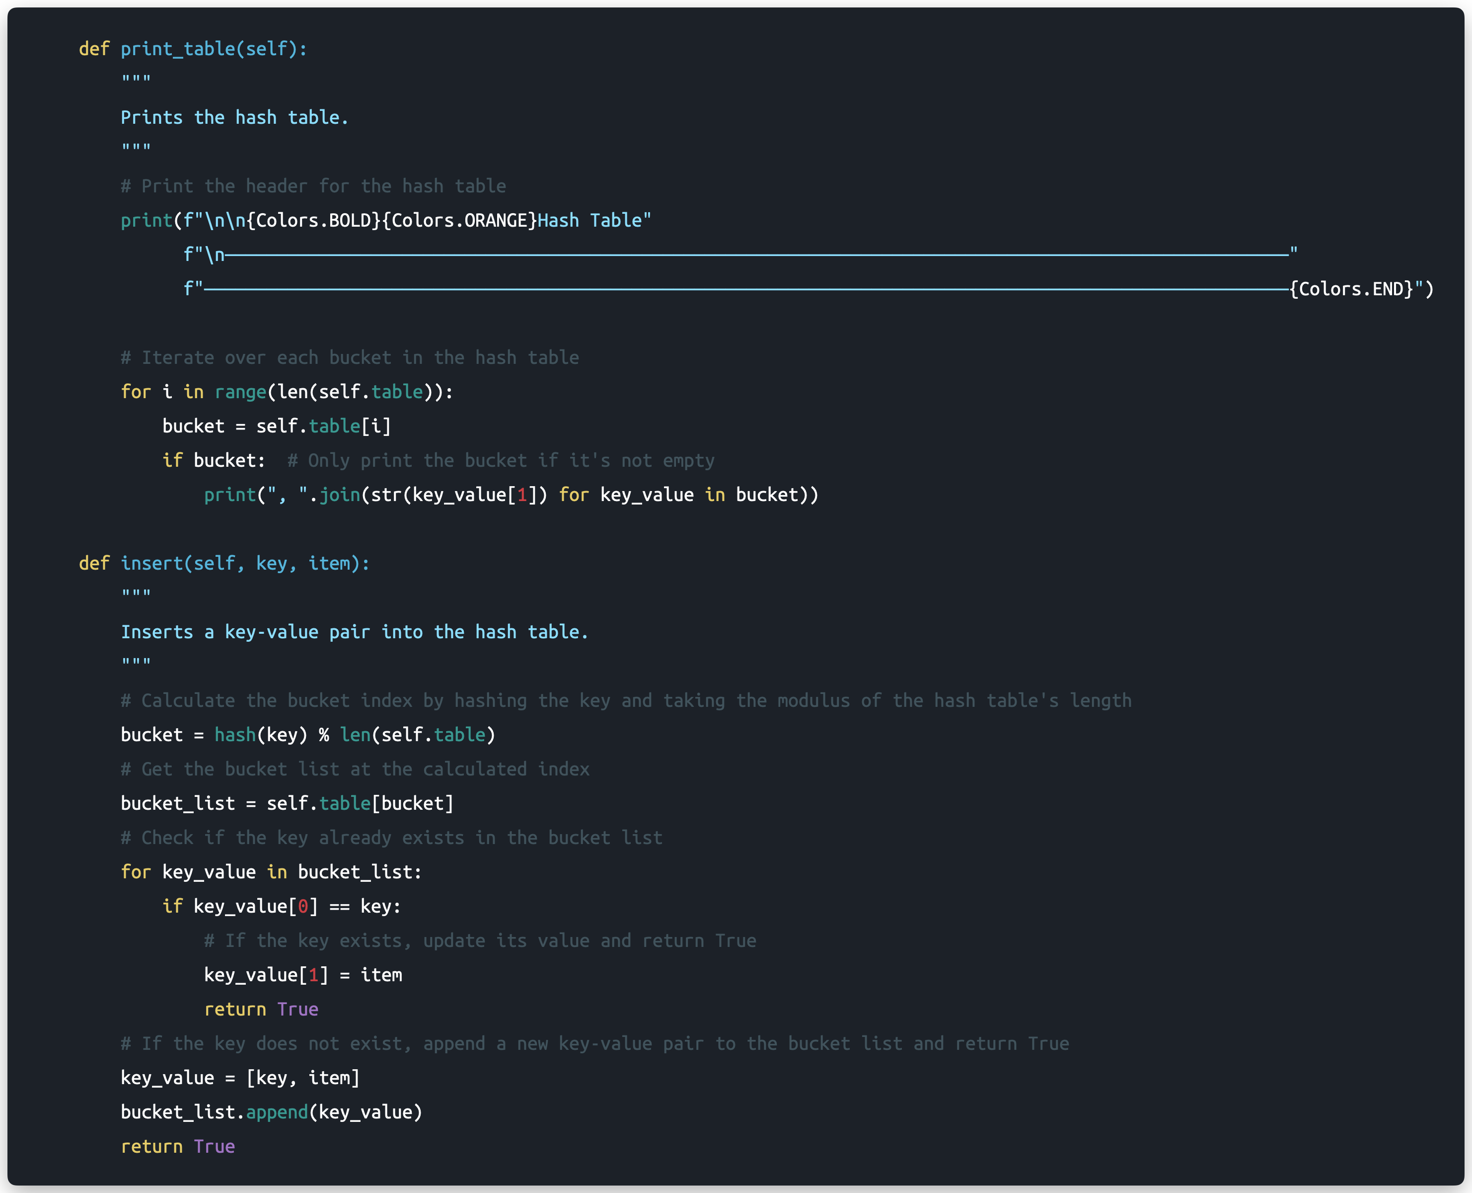

Chaining Hash Table – Process and Flow Comments (Continued)

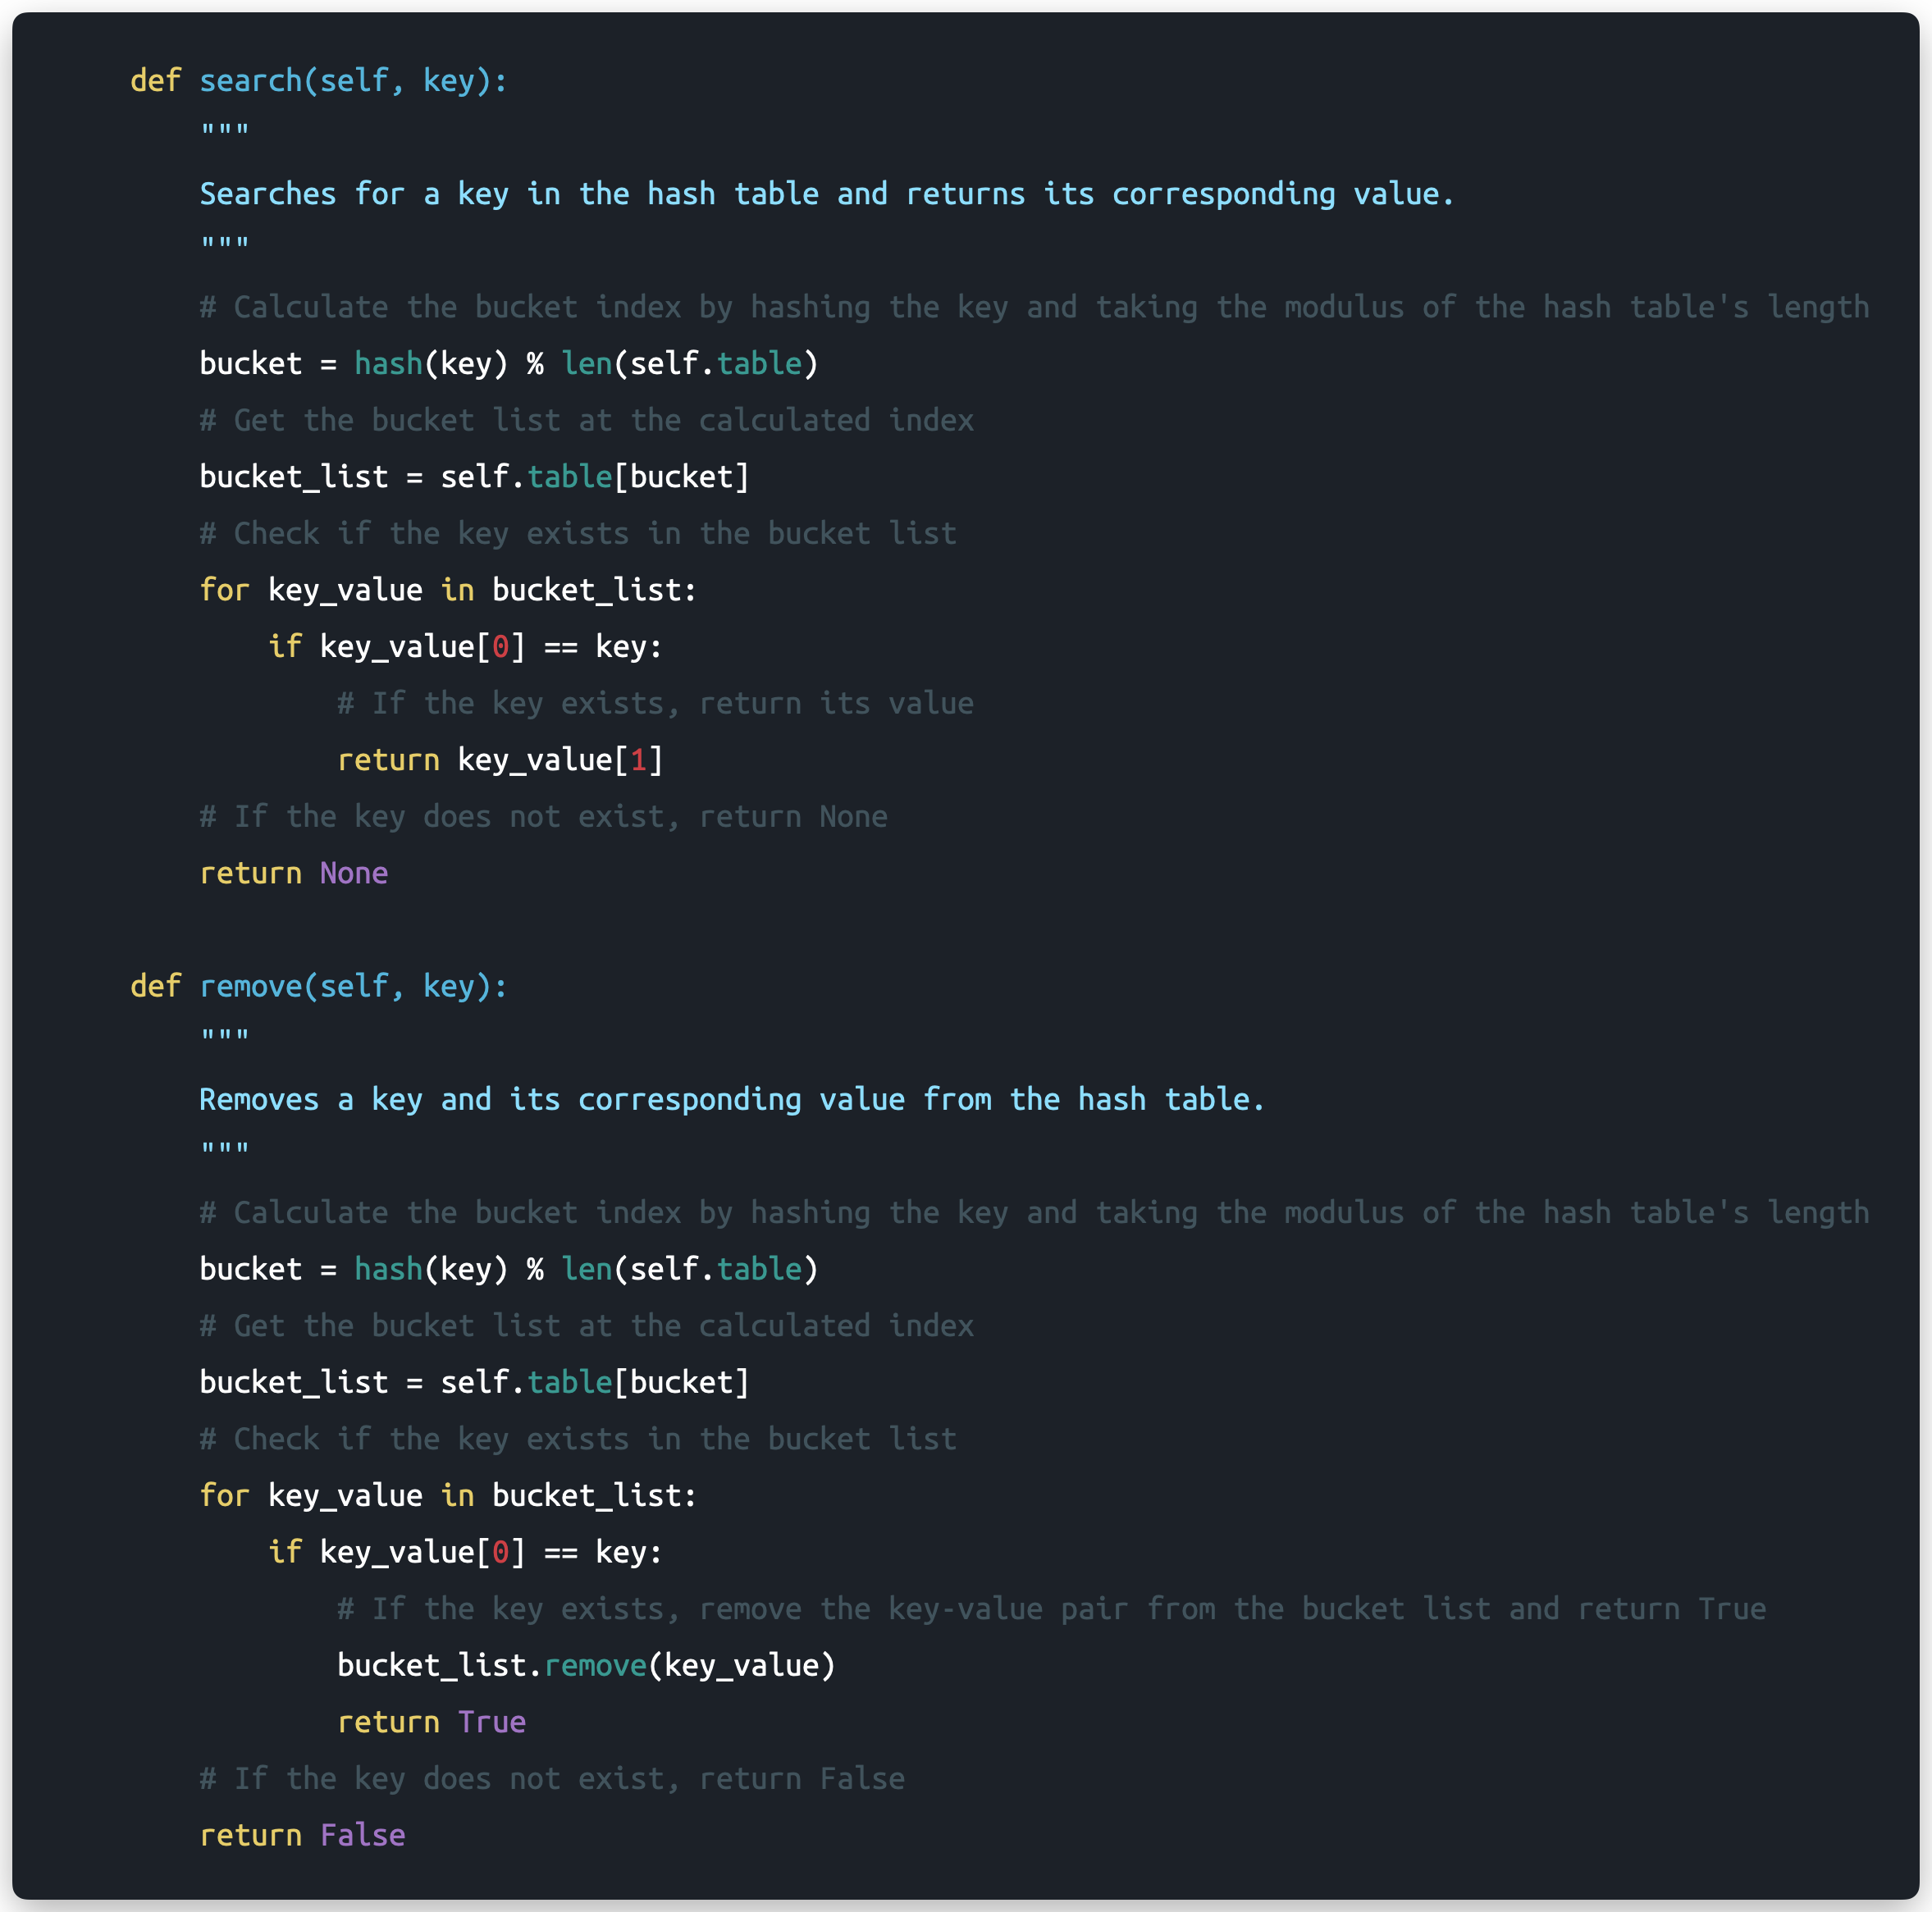

Greedy Algorithm Function – Process and Flow Comments



Greedy Algorithm Function – Process and Flow Comments (Continued)



Greedy Algorithm Function – Process and Flow Comments (Continued)



# D. Interface

User Interface – Initial Execution

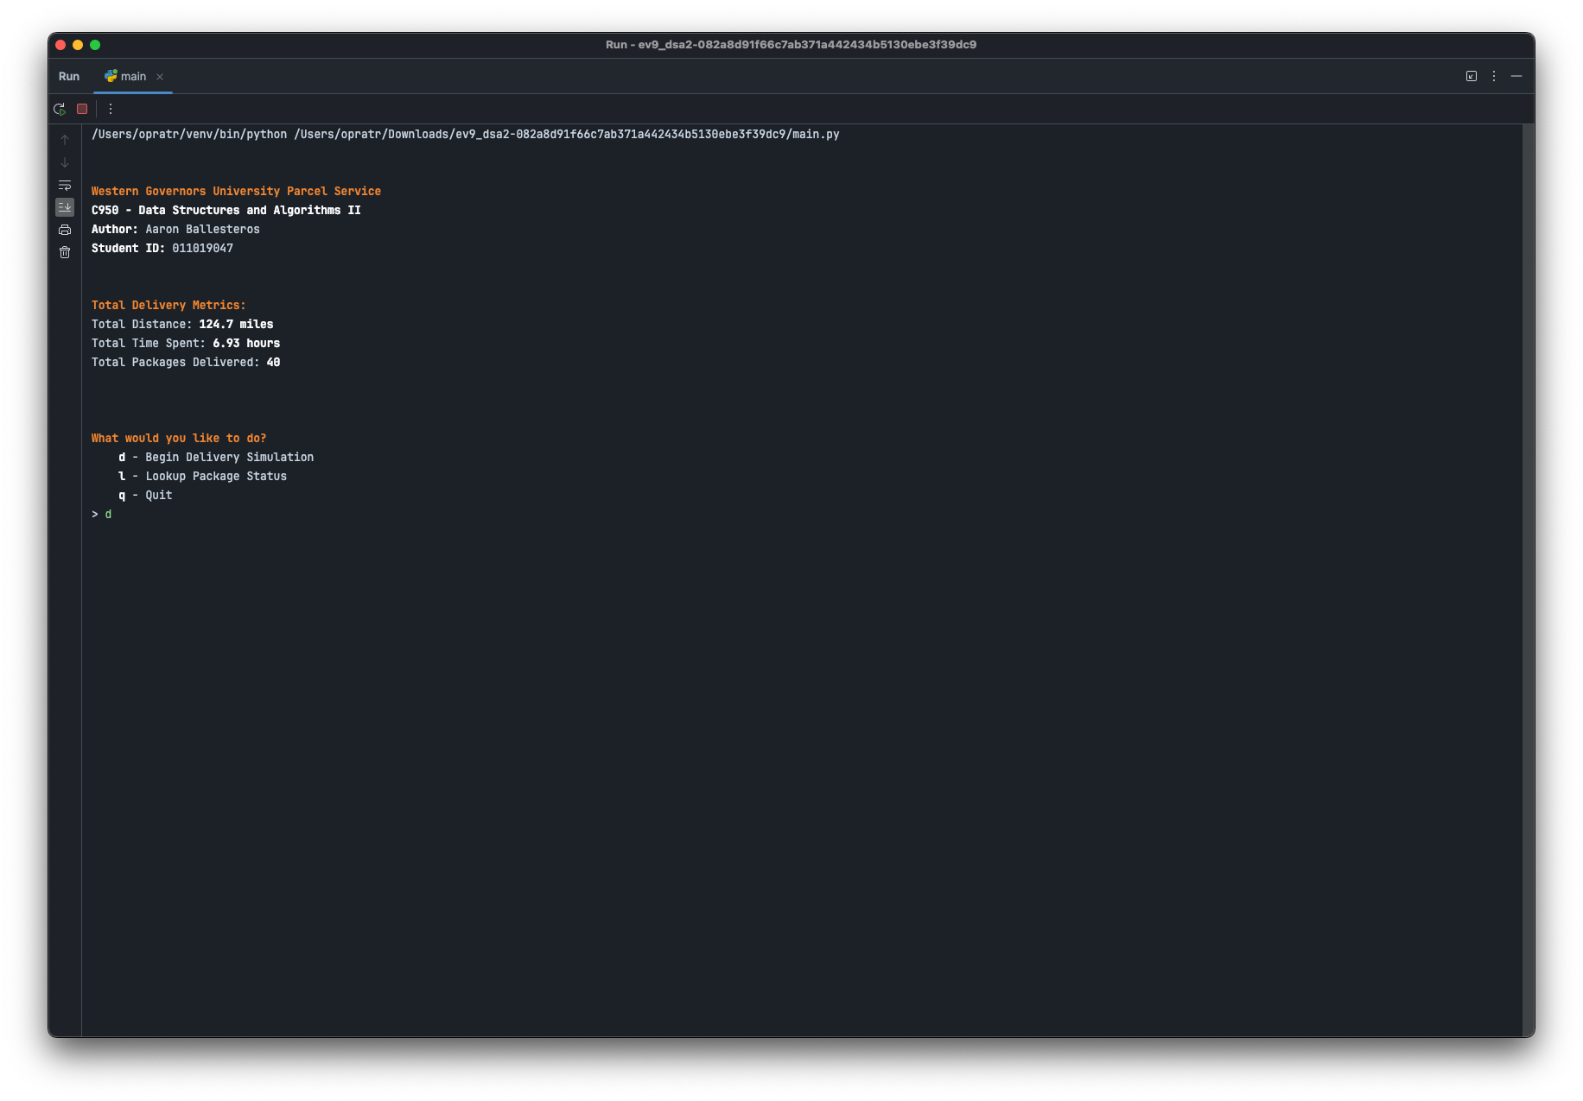

# D1. First Status Check

Figure 1 - Status Check 9:00am

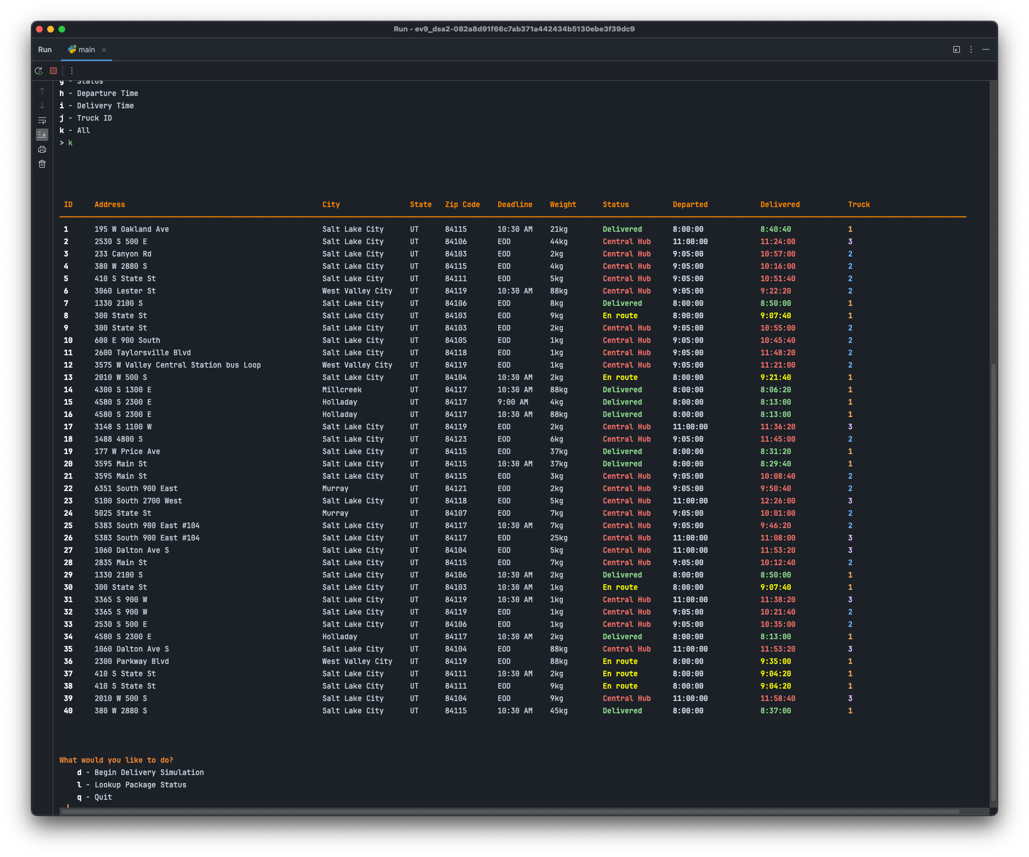

# D2. Second Status Check

Figure 2 - Status Check 10:15am

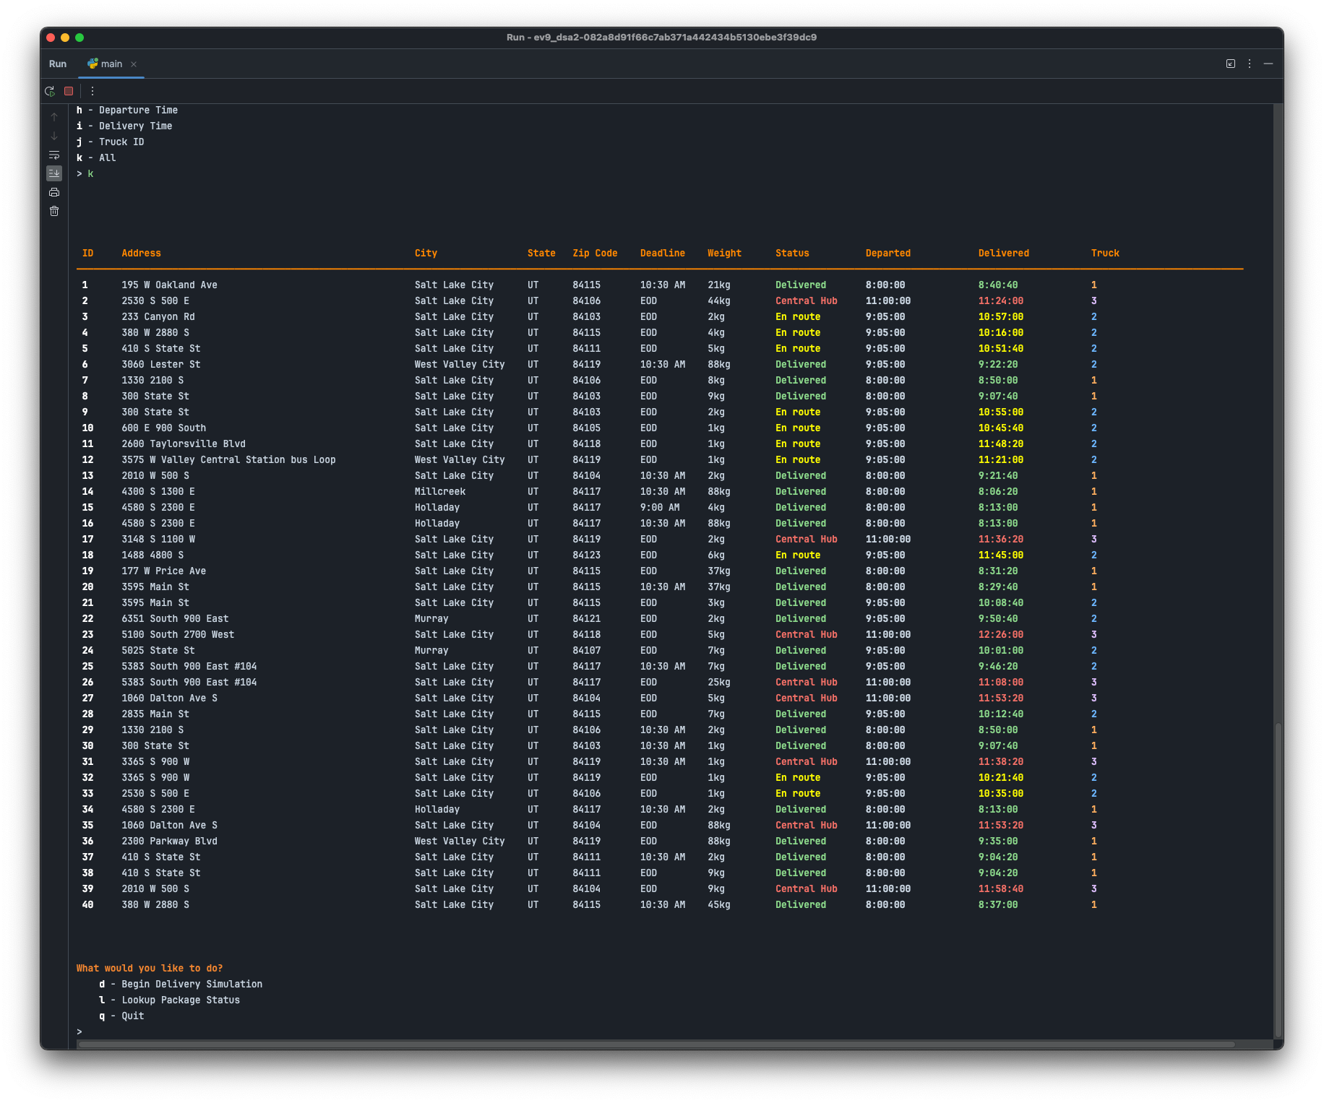

# D3. Third Status Check

Figure 3 - Status Check 12:30pm

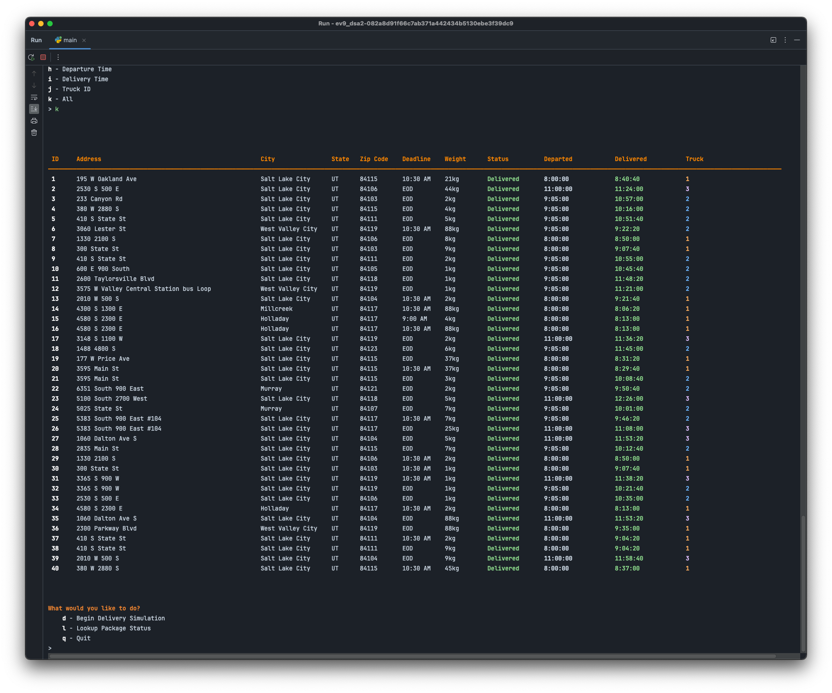

# E. Screenshot of Code Execution

Delivery Simulation – Code Execution

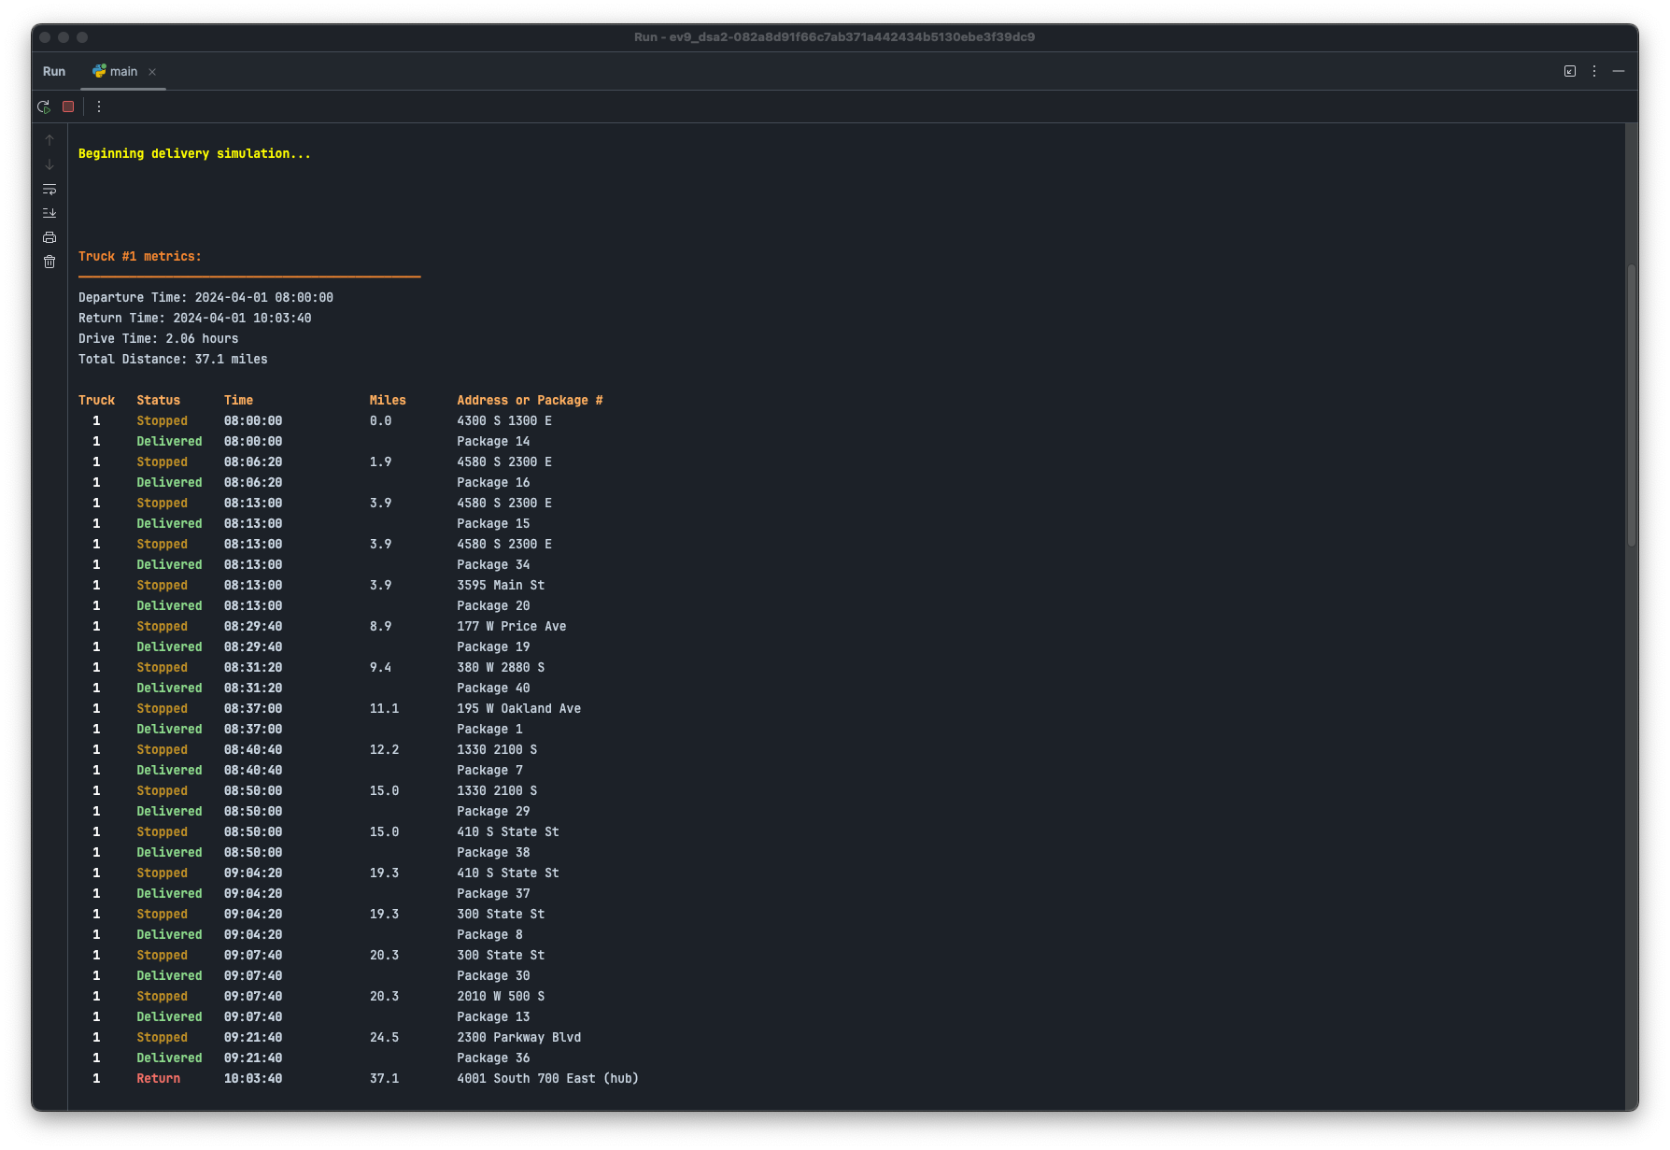

Delivery Simulation – Code Execution (Continued)

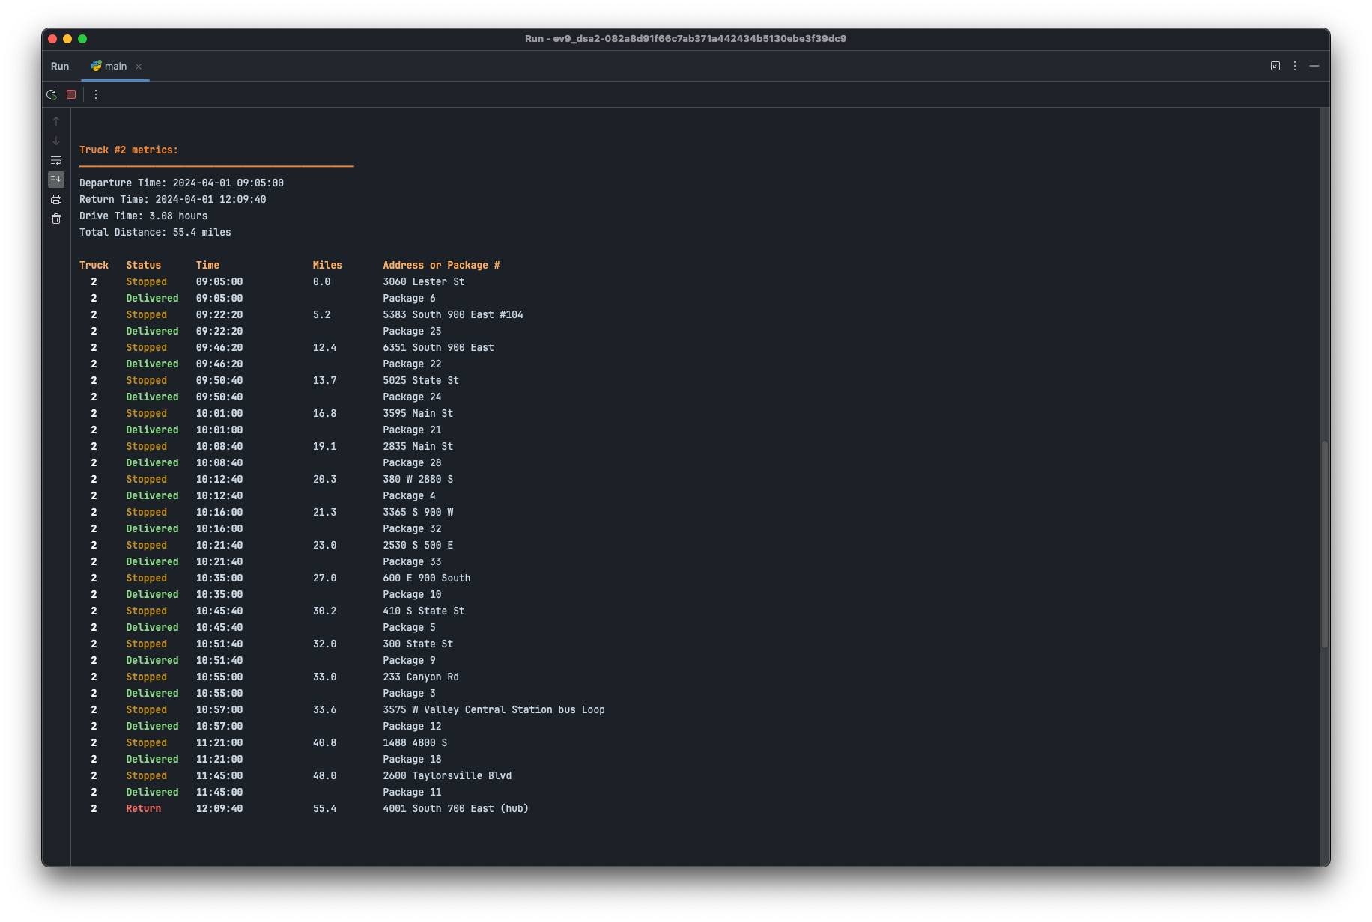

Delivery Simulation – Code Execution (Continued)

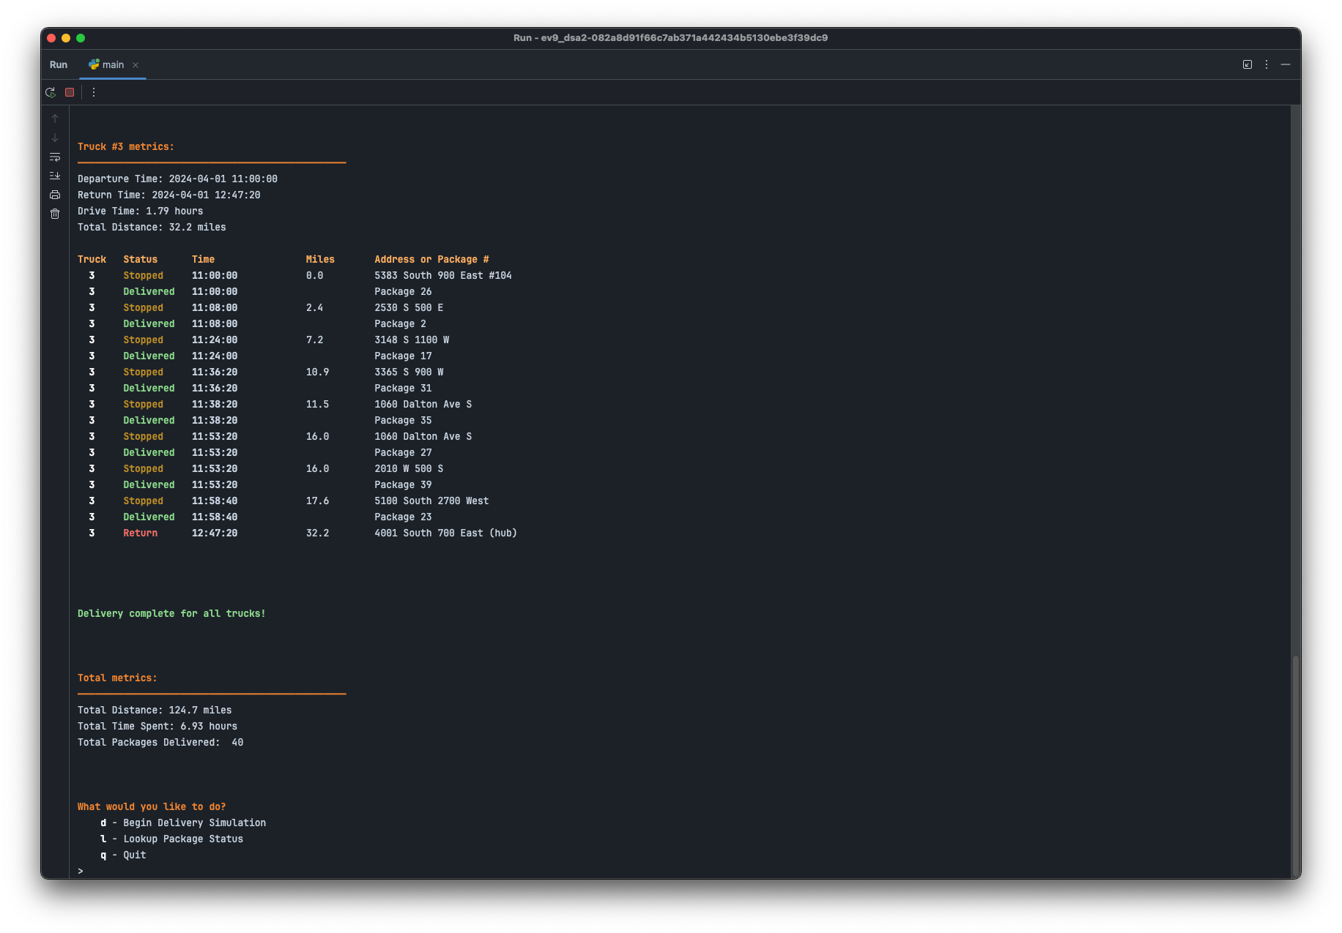

# F1. Strengths of the Chosen Algorithm

This delivery system makes use of a greedy algorithm that has two main strengths: simplicity and efficiency. Notably, in an environment where the need is for the quickest and most efficient course of action with swift decision-making, it is the simplest and most efficient. For instance, “Greedy algorithms are often faster than other optimization algorithms, such as dynamic programming or branch and bound, because they require less computation and memory.” (GeeksforGeeks, n.d.). In a similar manner, dynamic capability adapts well to variable conditions, which suit delivery systems where operational variables may change their state in an unpredictable way.

# F2. Verification of Algorithm

The Greedy algorithm will follow each condition that is specified, from time conditions that constrain deliveries to grouped conditions for delivery. This is an algorithm that has real-time truck routing and scheduling efficiently managed, ensuring that all the packages are delivered within the specified time and under group conditions. For instance, “The greedy approach can be used to solve problems in real-time, such as scheduling problems or resource allocation problems, because it does not require the solution to be computed in advance.” (GeeksforGeeks, n.d.). This is realized in the operational scenarios, which vary, and, therefore, proves the robustness of the algorithm in maintaining compliance with the delivery stipulations.

# F3. Other Possible Algorithms

Alternative algorithms that could enhance the delivery system include Dijkstra's Algorithm and Kruskal's Algorithm. Dijkstra can find the shortest path in a weighted graph; thus, it can be used to ensure the delivery route by distance and time is the shortest. This way, it minimizes operational costs. On the other hand, Kruskal's algorithm generally finds its way in the development of the minimum spanning tree from a connected weighted graph that would in totality optimize the network by reducing the total distance traveled among all the routes.

# F3a. Algorithm Differences

The main differences from the implemented greedy approach are notable with these algorithms. In this case, Dijkstra's Algorithm would dynamically calculate the shortest path to the next delivery point for each segment, choosing a route in an optimized way continuously, as opposed to the current type of selecting the closest package without guarantees of route efficiency. Contrariwise, Kruskal's Algorithm focuses not on the optimization of individual delivery paths but on optimizing by way of the minimum total travel distance for a collective set of deliveries points.

# G. Different Approach

If I had an opportunity to redo the project, I would, without a doubt, go for a much more modular organizational structure of the codebase. To dismantle the project into several external modules would improve not only the readability but also the maintainability of the project. Each of these could focus on some specific functionalities, such as routing algorithms, user interfaces, and data management, among others. Furthermore, deploying more advanced routing algorithms such as Dijkstra's would offer vital input towards refining the effectiveness of route planning, thus improving delivery times and operational costs. It would make sense to implement Dijkstra's algorithm because “the algorithm uses a greedy approach to solve the problem.” (Nagaraj, 2023).

# H. Verification of Data Structure

The Hash Table used in the delivery system scenario structure serves the purpose appropriately. Effective search and update of package data can be made fast, hence meeting the requirement that the delivery status must be up to date all the time.

# H1. Other Data Structures

Apart from those mentioned above, other data structures can be used to meet such requirements, for example, Binary Search Trees (BST) and graphs. Binary Search Trees helps in maintaining data in a very organized fashion so that it becomes very easy to conduct search, insertion, and deletion operations on that data. This feature is, however, meant for providing sorted delivery reports or management of data that benefits from being ordered. On the other hand, the graphs, by their locations as nodes and routes as edges, easily fit in the context of delivery. It enables the application of various routing algorithms and provides a mannered way of exploring the delivery network.

# H1a. Data Structure Differences

One of the most important differences between a Binary Search Trees and Hash Tables is that while Binary Search Trees maintains the element order, sometimes it is necessary for the operations in question to maintain the order of data. For example, median computation or chronological reporting, among others. Graphs model relations and distances between nodes (delivery points), in contrast to Hash Tables, which model items requiring fast direct access but do not have inherent relation mapping. In relation to routing and navigation in the delivery network context, it makes graphs particularly useful.

# I. Sources

Nagaraj. (2023, February 20). Dijkstra's algorithm: An overview 2023. Medium. Retrieved April 14, 2024, from <https://cyberw1ng.medium.com/dijkstras-algorithm-an-overview-2023-da70f17528d6/>.

GeeksforGeeks. (n.d.). Greedy algorithms: General structure and applications. Retrieved April 14, 2024, from <https://www.geeksforgeeks.org/greedy-algorithms-general-structure-and-applications/>.